CA1: Rendering Foundations

For this CA, I’ve decided to make the subject of my render an industrial barrel from the [factory asset pack](https://assetstore.unity.com/packages/3d/props/industrial/abandoned-factory-lite-62597).

# Demo scene

To start, I began by setting up the controlled test scene. This scene is an enclosed space with some simple assets and a night skybox. This scene will be used to test for PBR and lighting correctness.

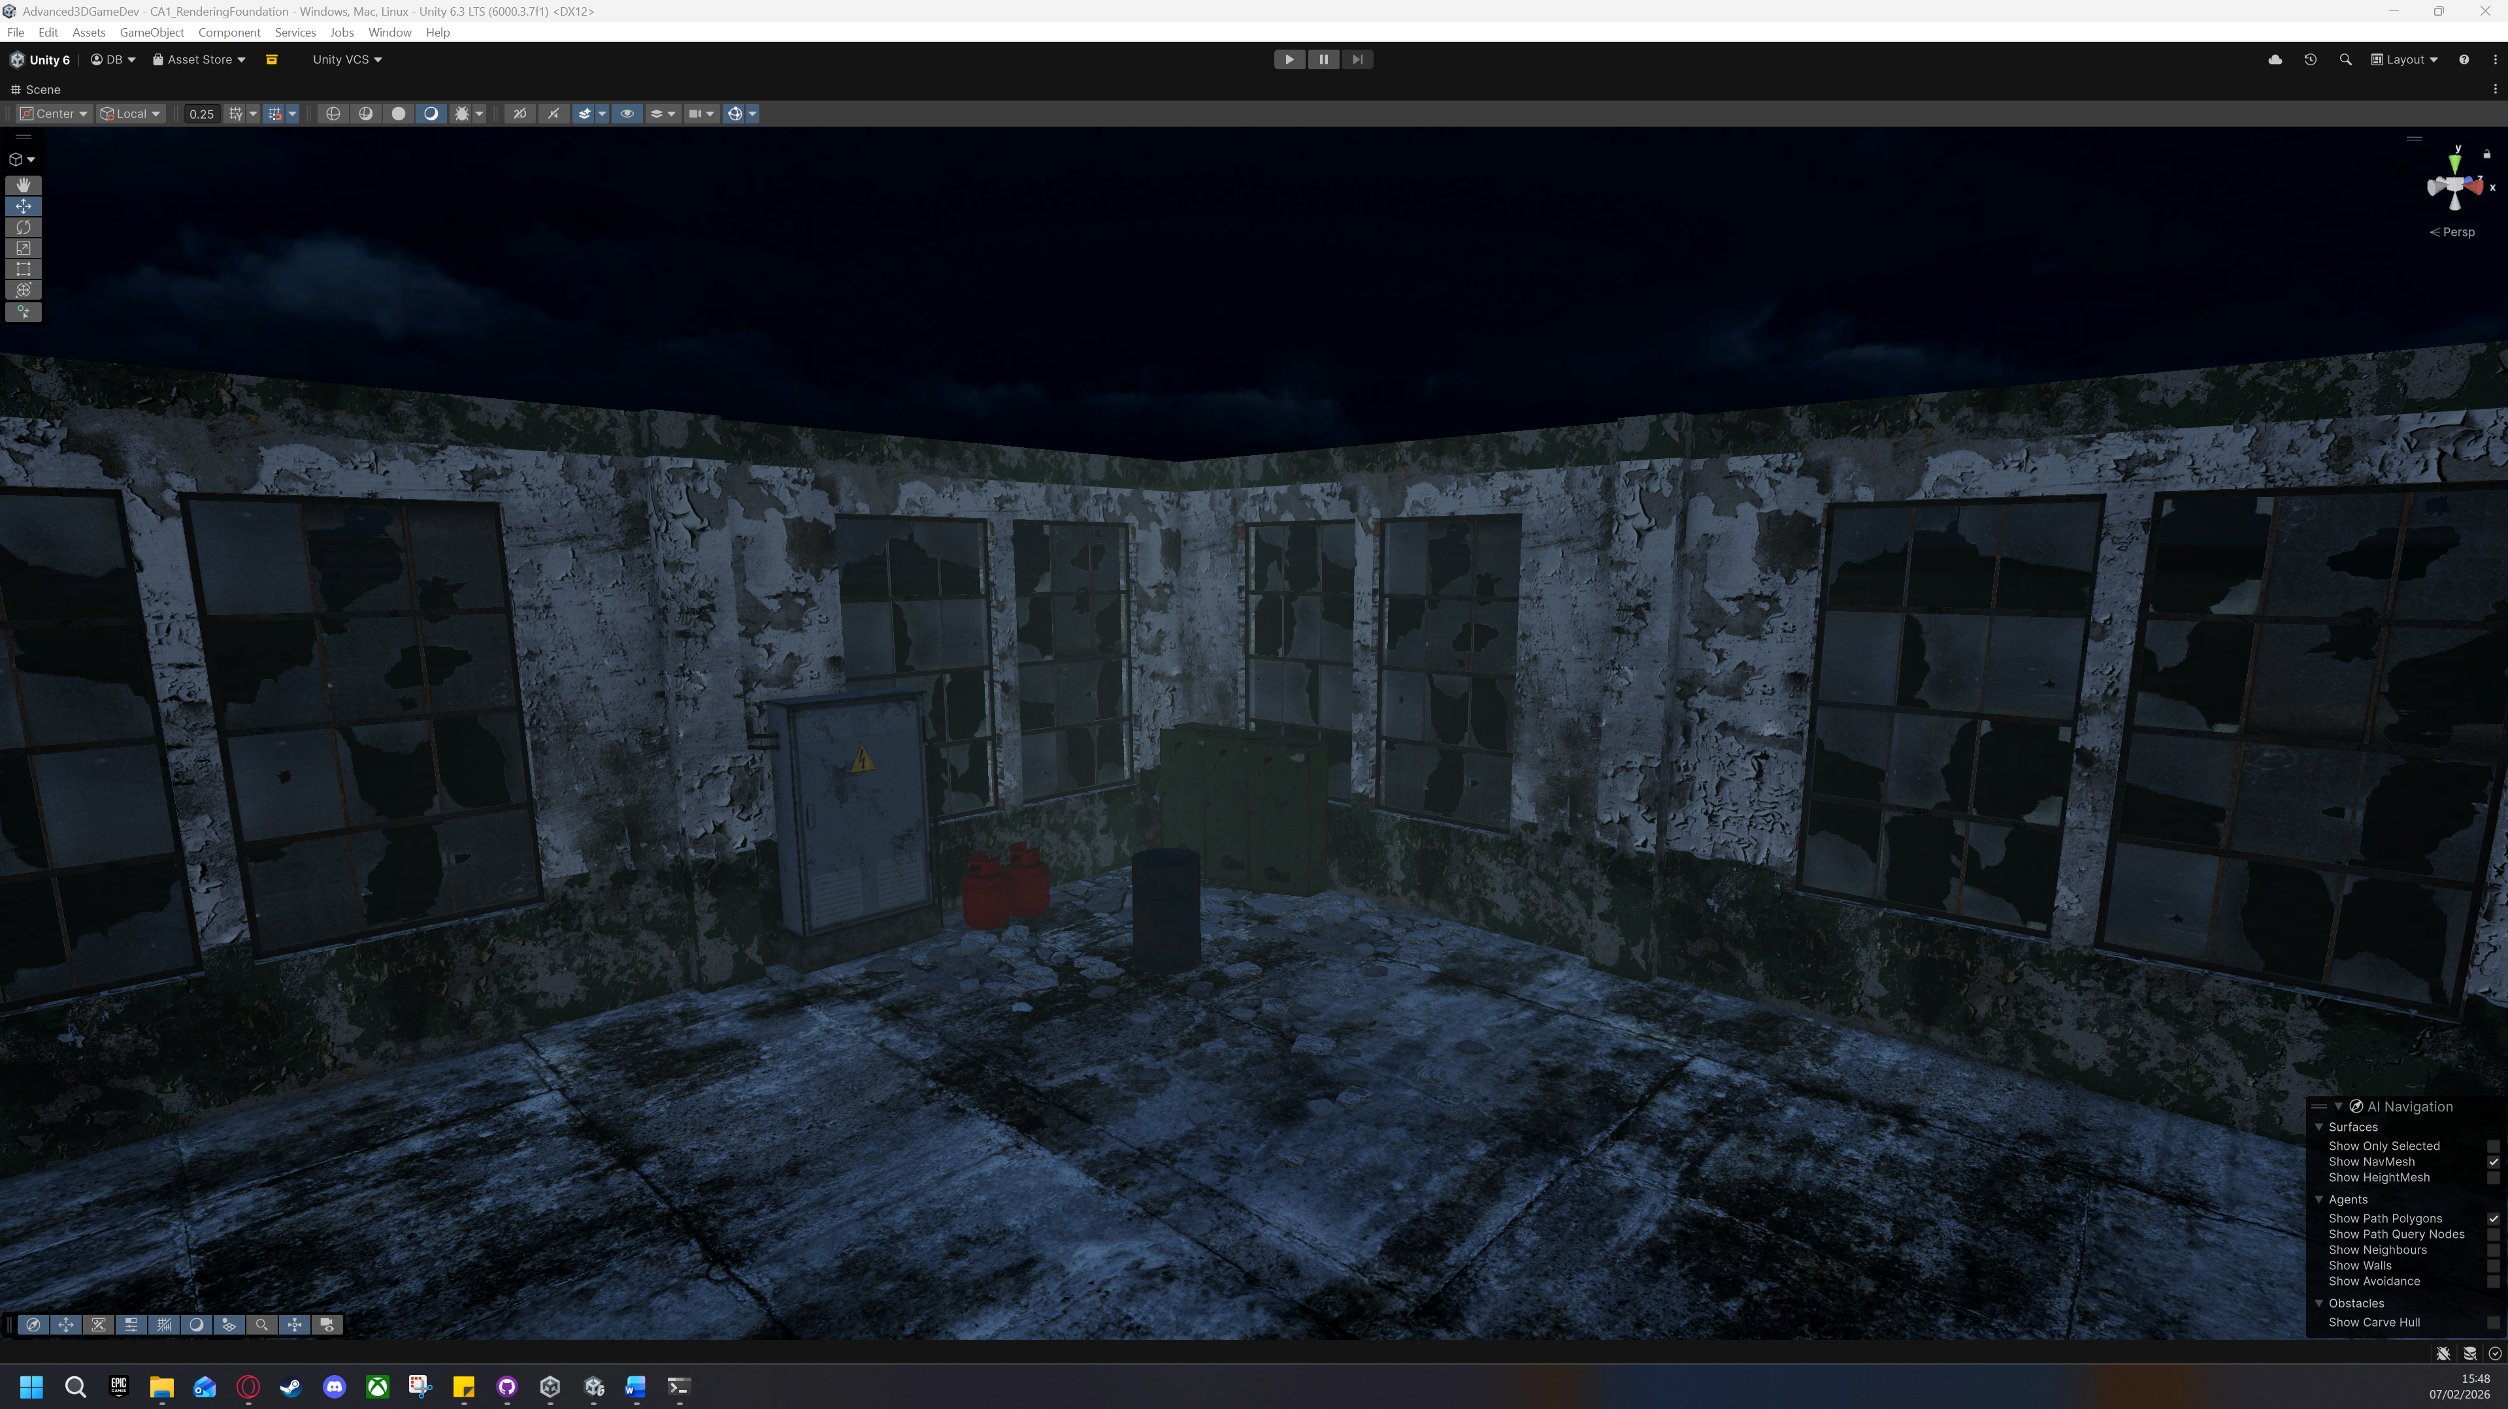

# Substance 3D painter

Using substance painter, I decided to create my own textures for one of the barrel models provided from the [factory asset pack](https://assetstore.unity.com/packages/3d/props/industrial/abandoned-factory-lite-62597).

## Importing

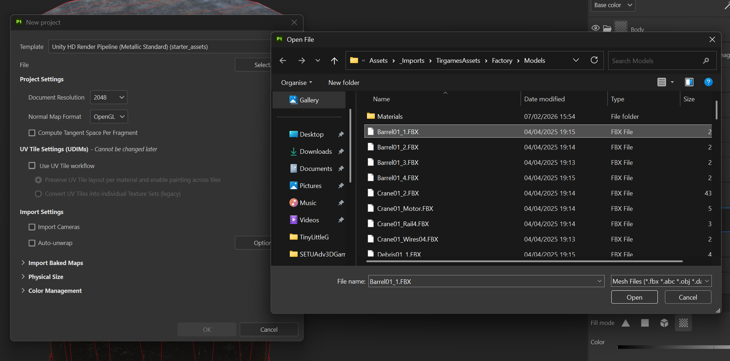

## Mesh baking

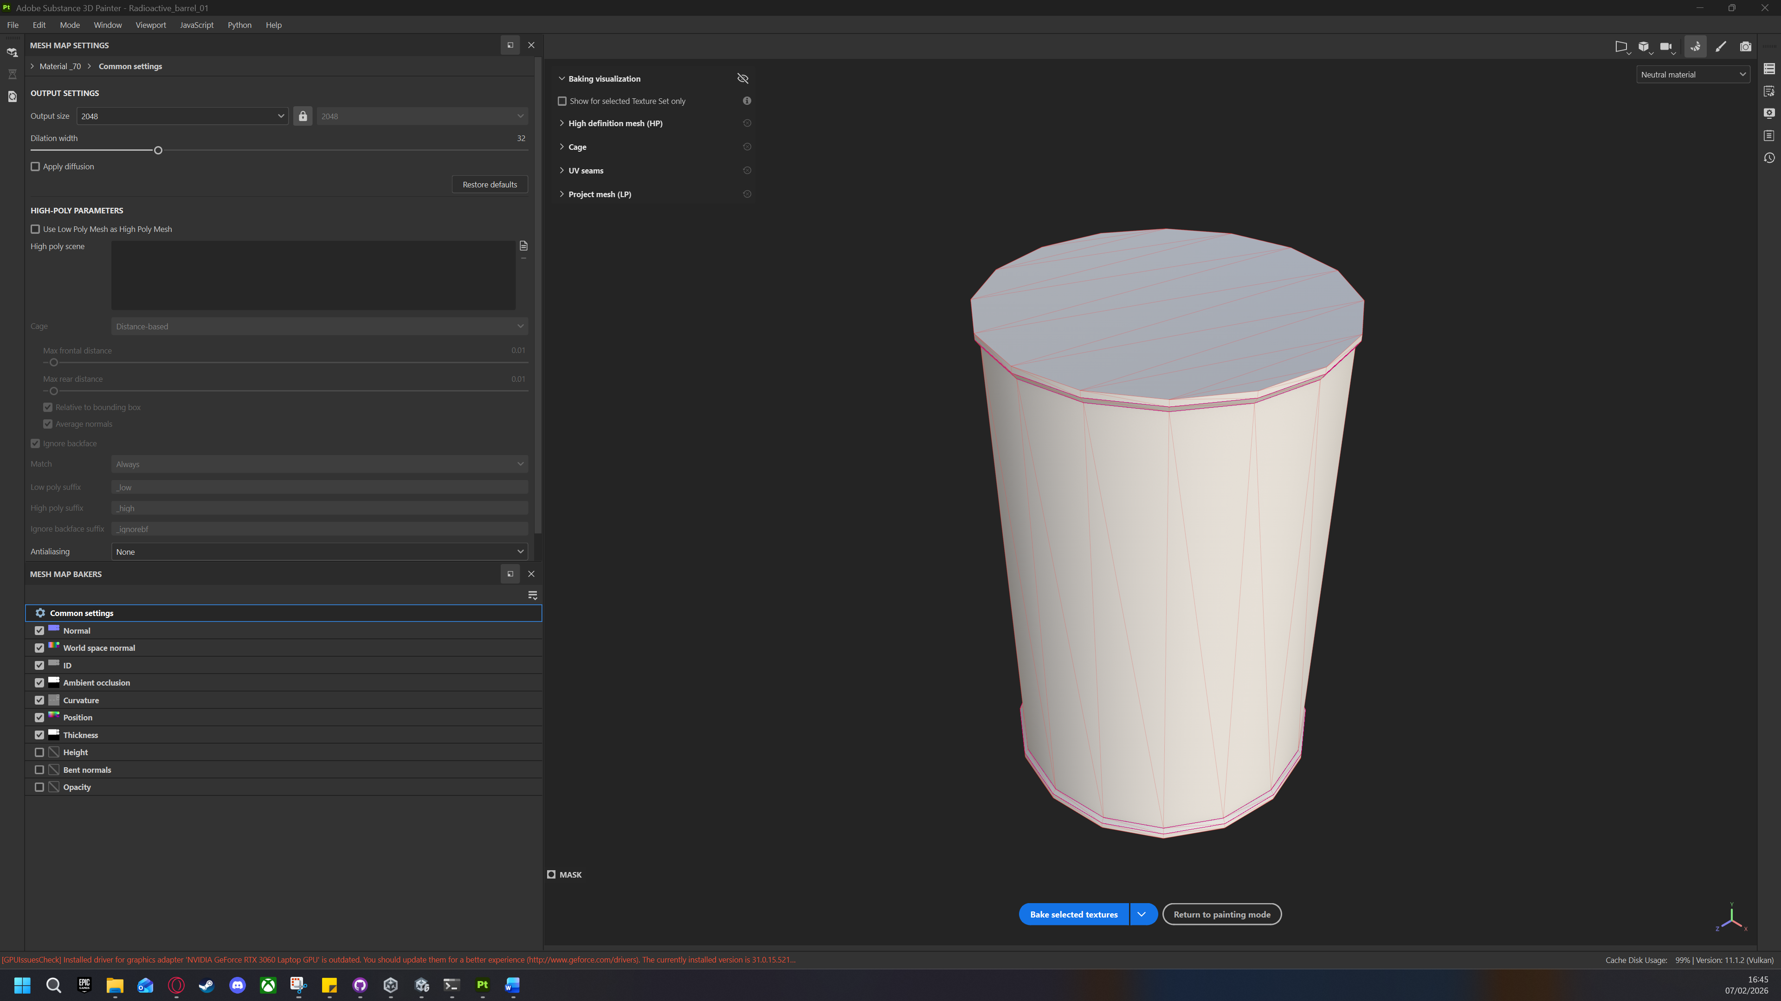

## Applying materials

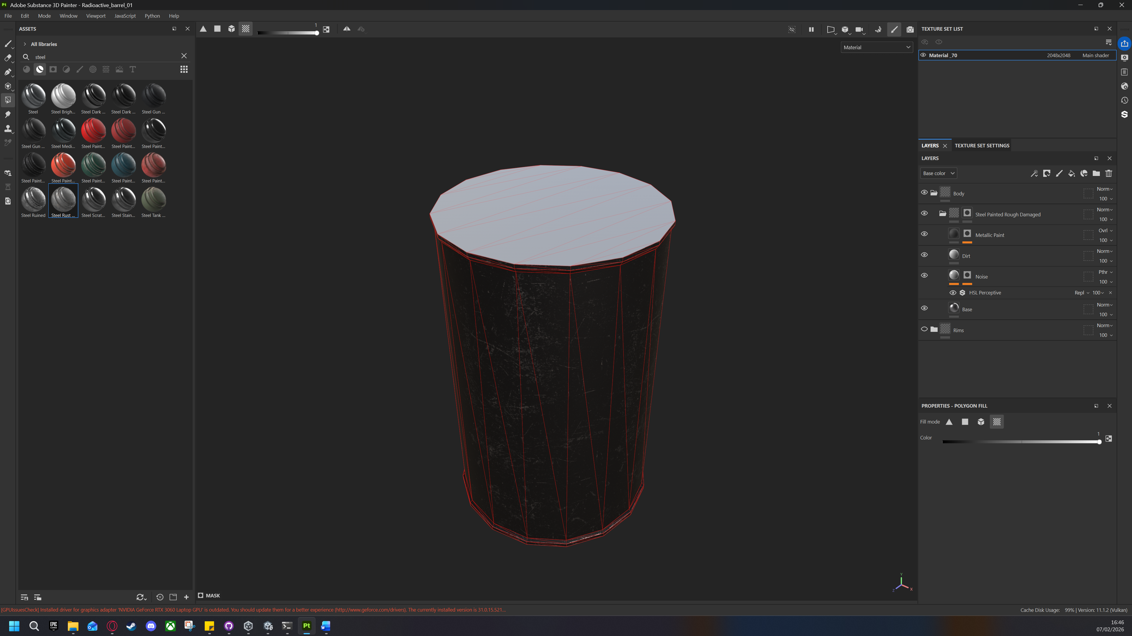

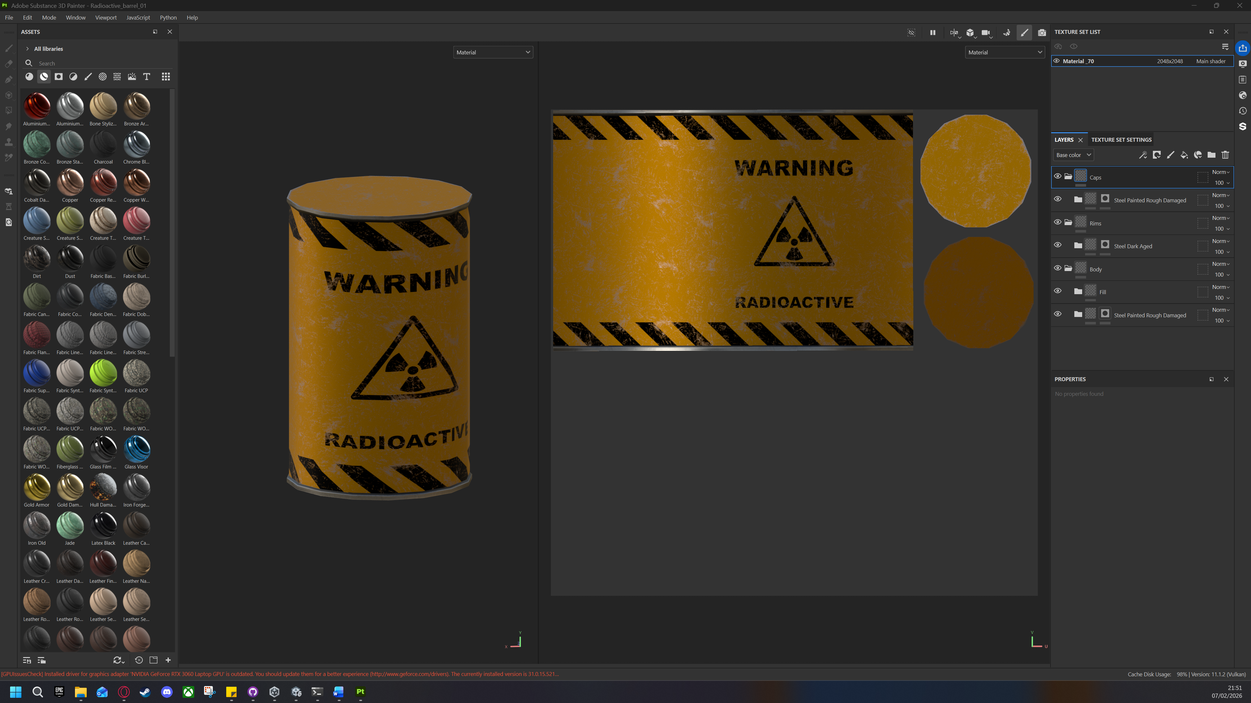

## Exporting to Unity

When exporting, set the file type to png and 16 bits.

By default, substance painter only comes with a metallic standard export for Unity URP. The metallic standard is missing the height map and ambient occlusion map.

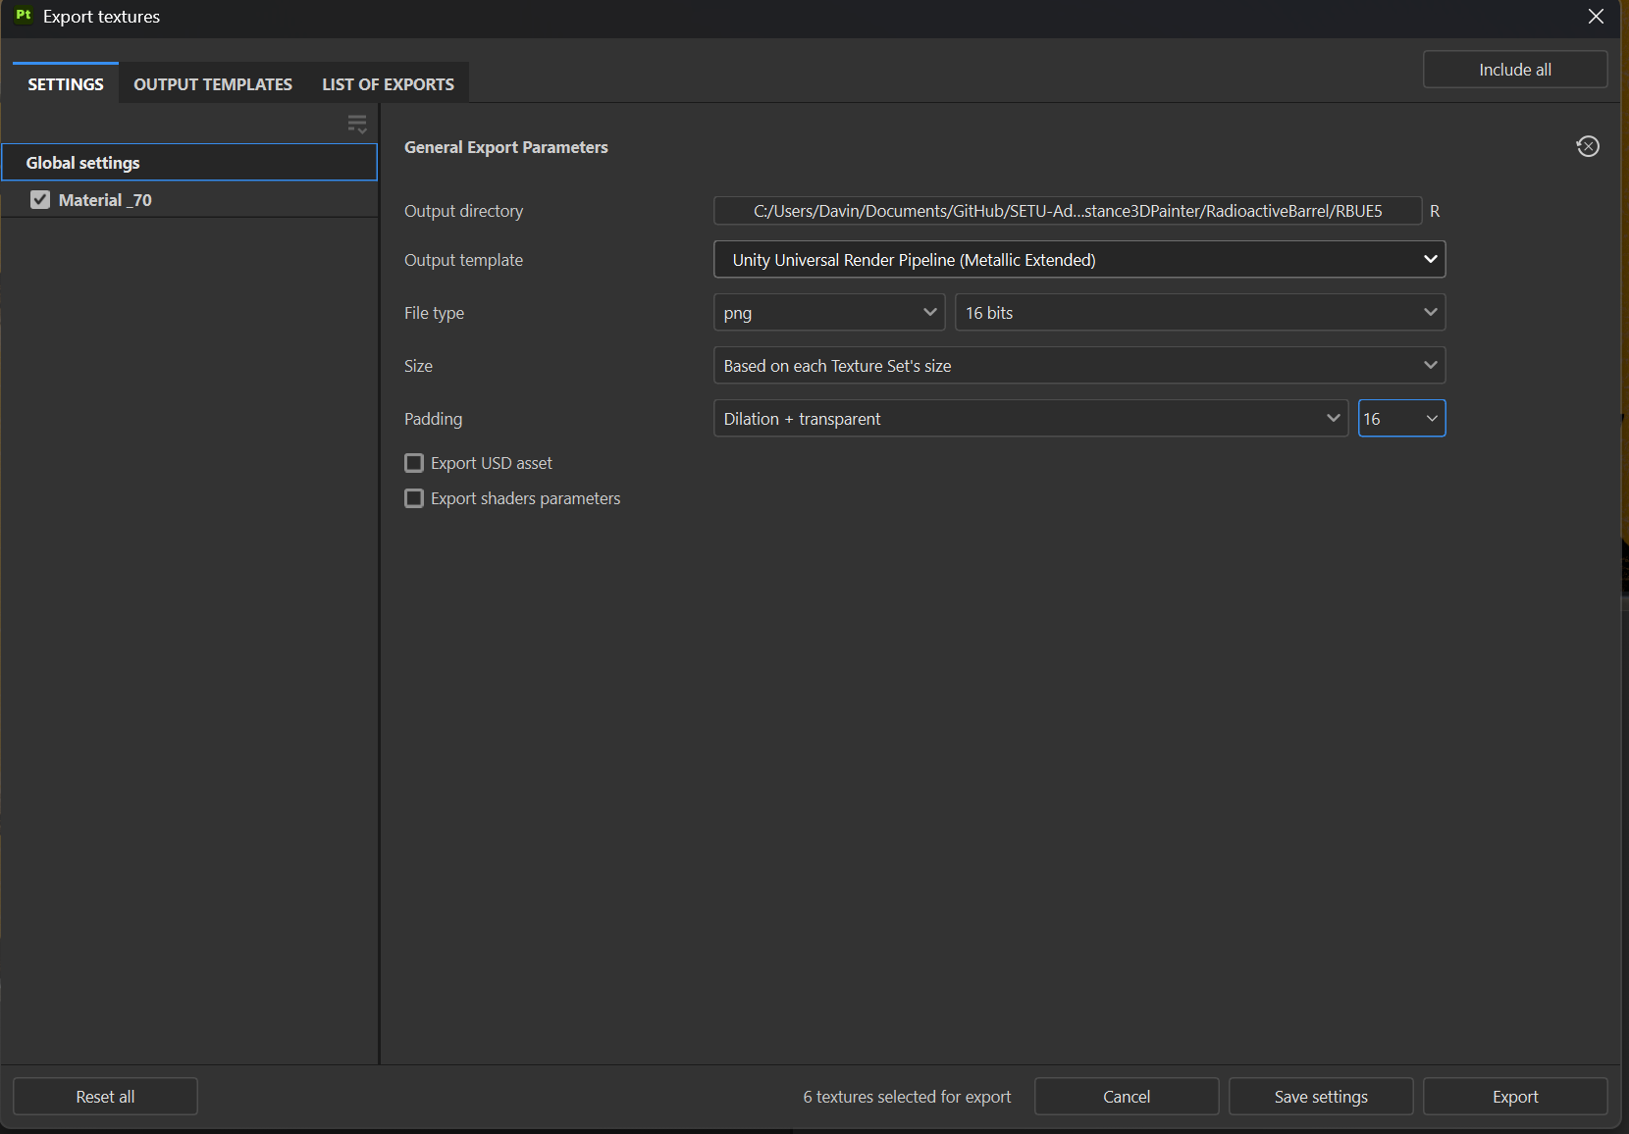

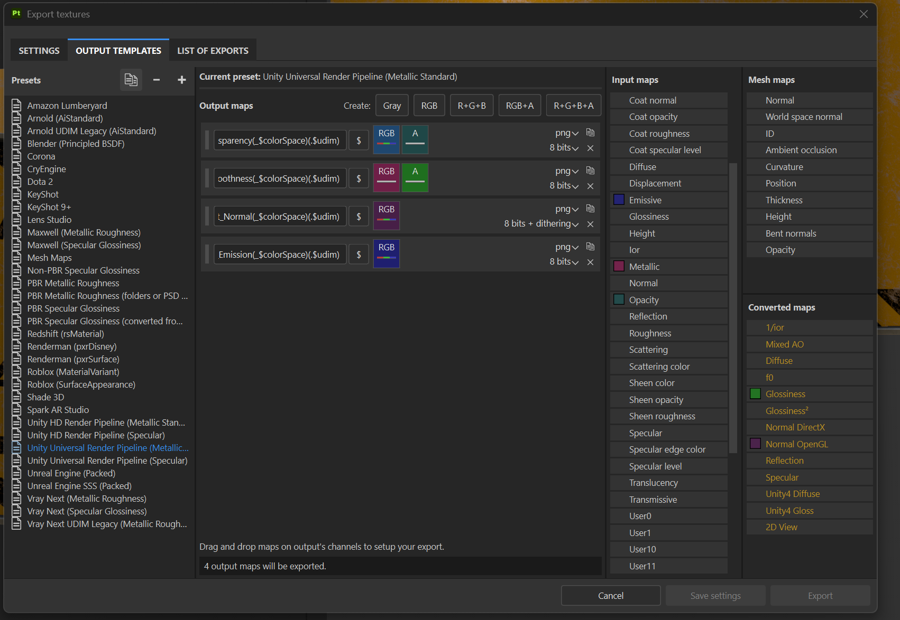

We can fix this by duplicating the metallic standard template and adding two more output maps like what we see in the screenshot below.

Height and ambient occlusion are data maps and use greyscale. For example, in a height map black values represent lows dips and white values represent high bumps.

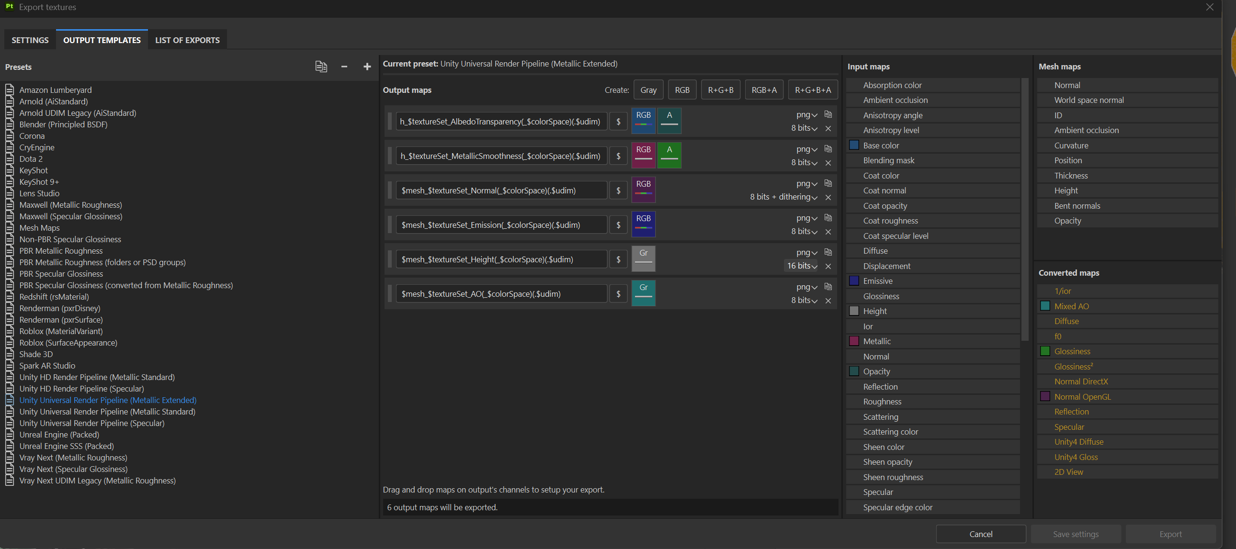

## Exporting to Unreal Engine

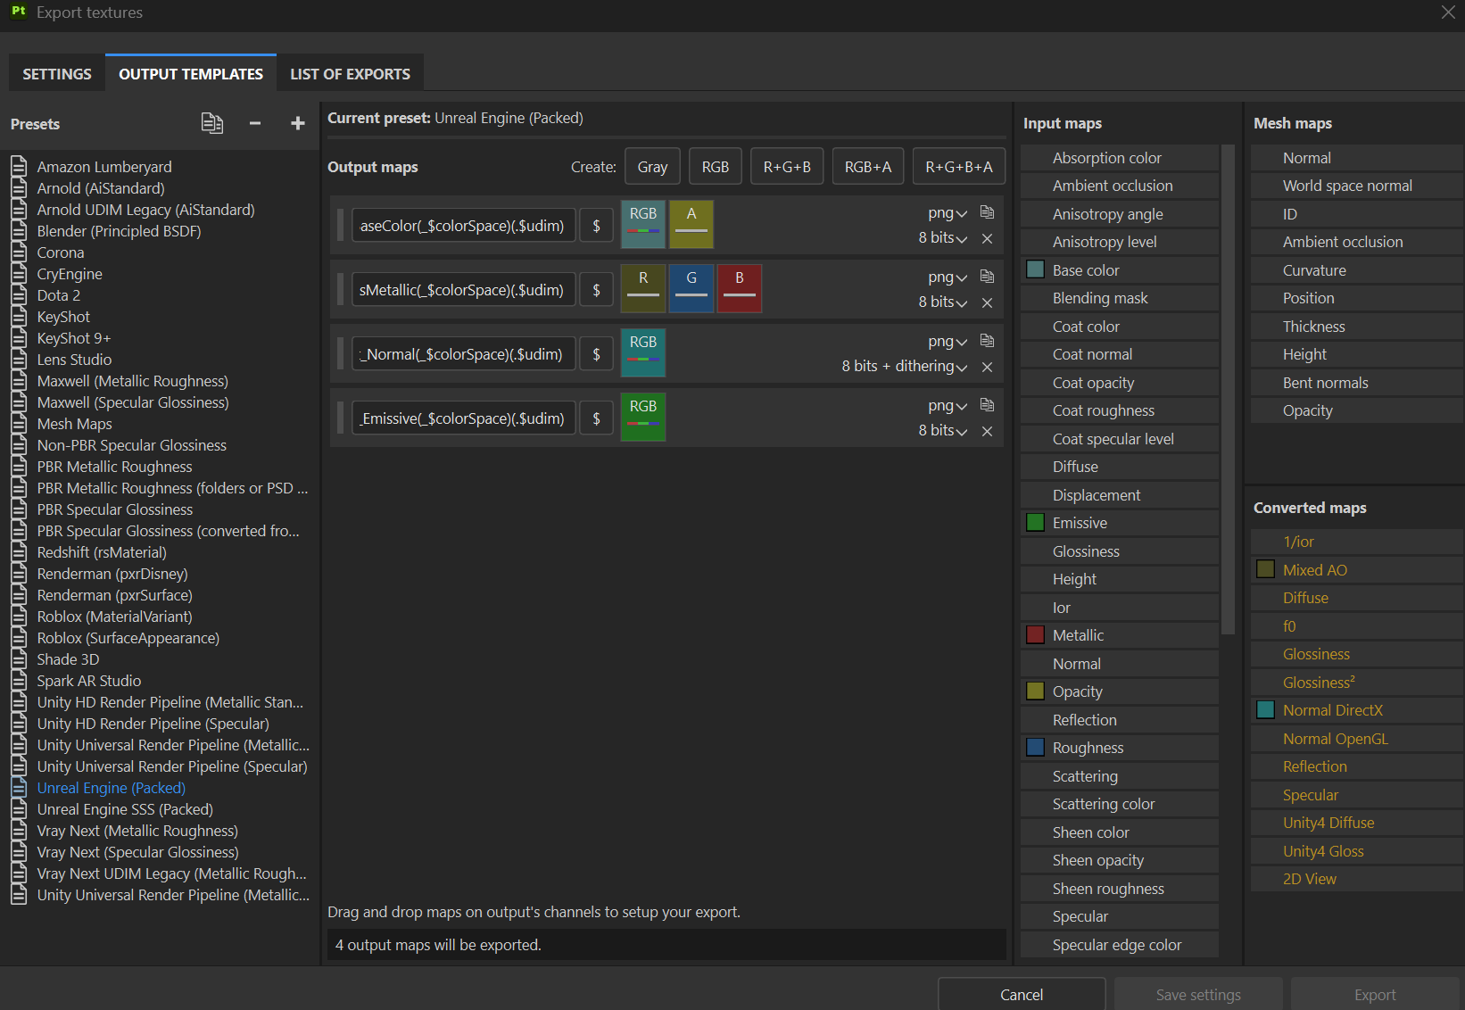

# Unity Import and PBR

We add the necessary textures exported from substance painter to the respective folder.

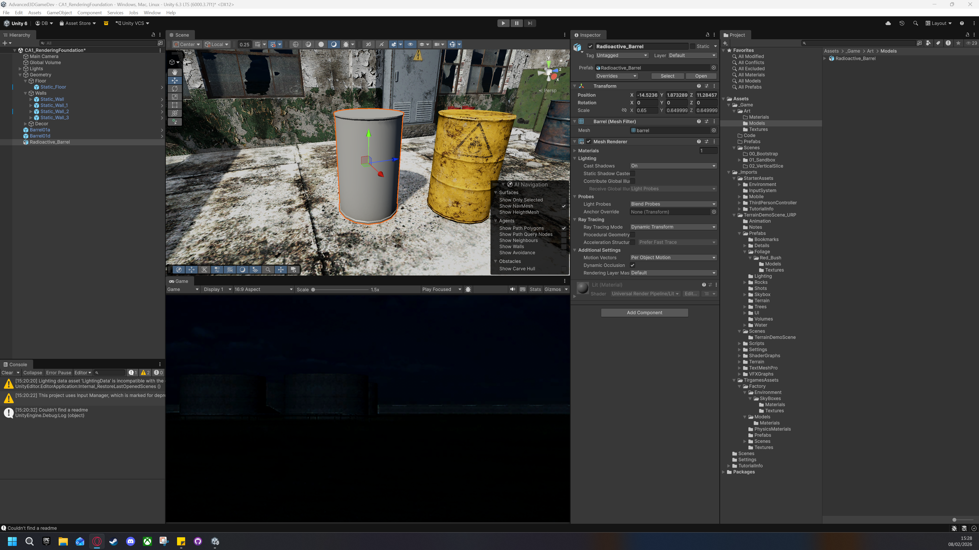

Created a new material called M_RadioactiveBarrel. Applied material to the barrel model.

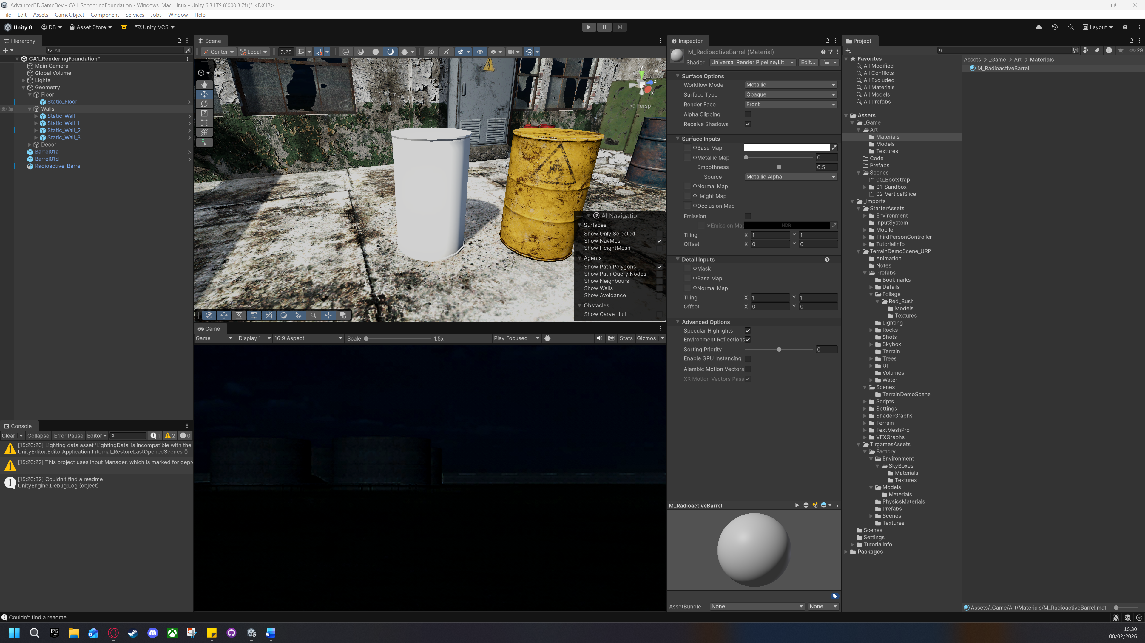

## Import Settings

In URP we use [Linear colour](https://docs.unity3d.com/6000.3/Documentation/Manual/linear-color-space.html#:~:text=Working%20in%20linear%20color%20space,working%20in%20gamma%20color%20space.&text=See%20in%20Glossary%20program%20are,Set%20a%20project%27s%20color%20space.) space, which causes light to behave mathematically correct.

Base Colour (Albedo) maps are imported with sRGB enabled, allowing Unity to handle gamma-to-linear conversion for human perceivable colour.

Normal, Metallic, and AO maps were imported with sRGB disabled to maintain data integrity. Because these maps represent physical properties rather than colour, any gamma-correction would shift the mathematical values, resulting in incorrect surface reflections and lighting artifacts. I provided some examples for the height map and metallic map differences with sRGB on and off to show this effect.

### Base Map

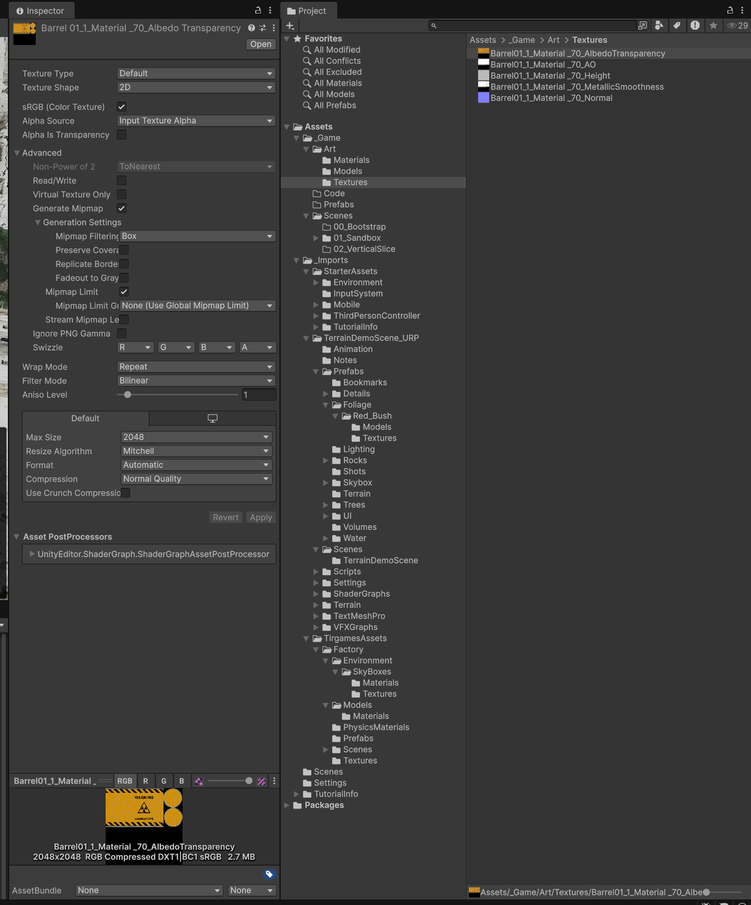

### Normal Map

The normal map texture type is incorrect when imported into Unity and must be changed in the texture settings to be a normal map as seen in the following screenshots.

This converts the RGB values from the map into XYZ vectors.

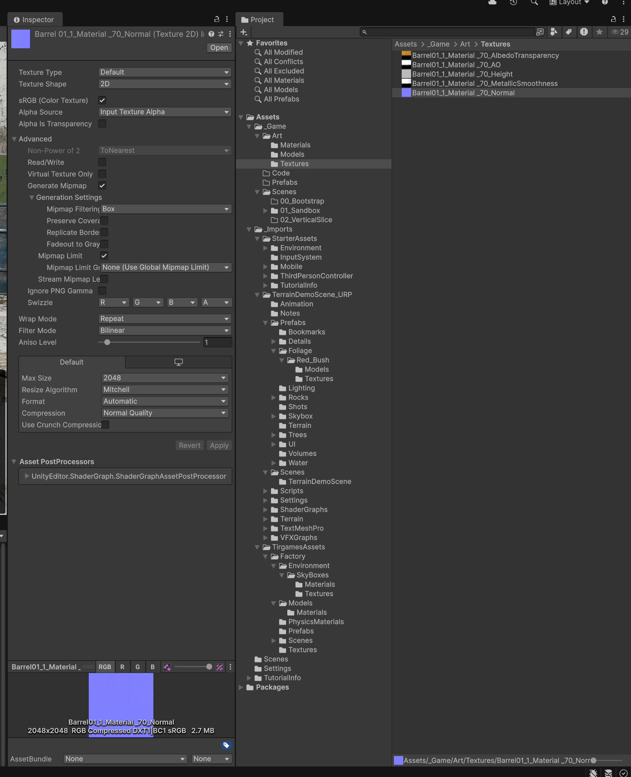



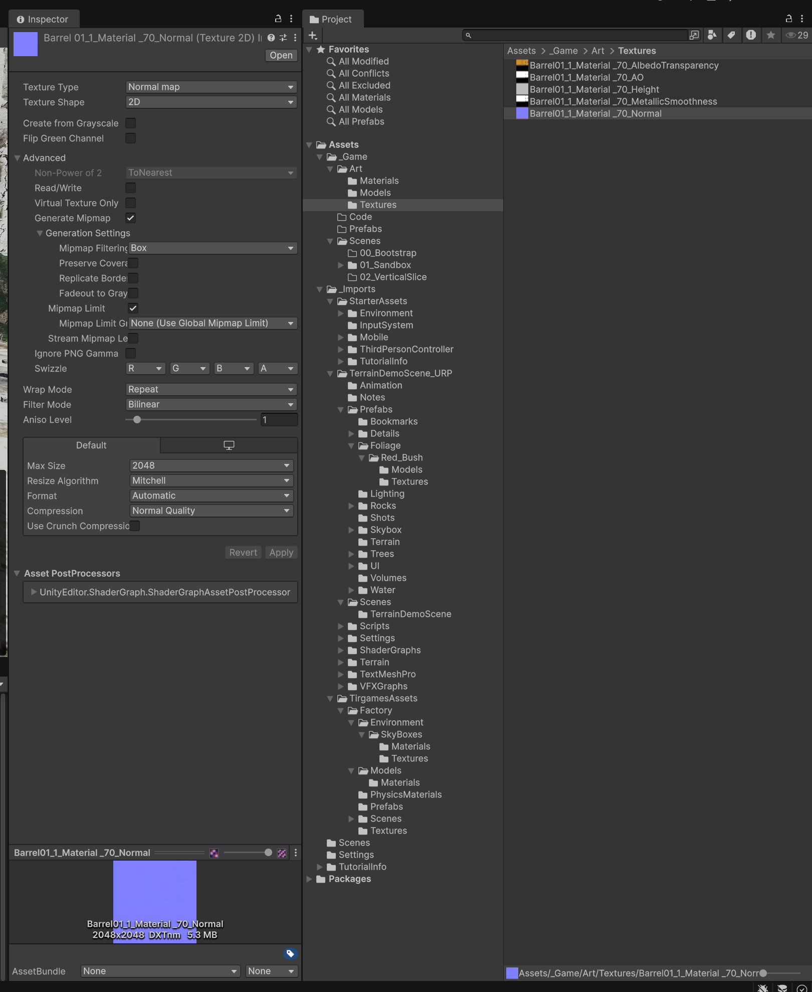



### Occlusion Map

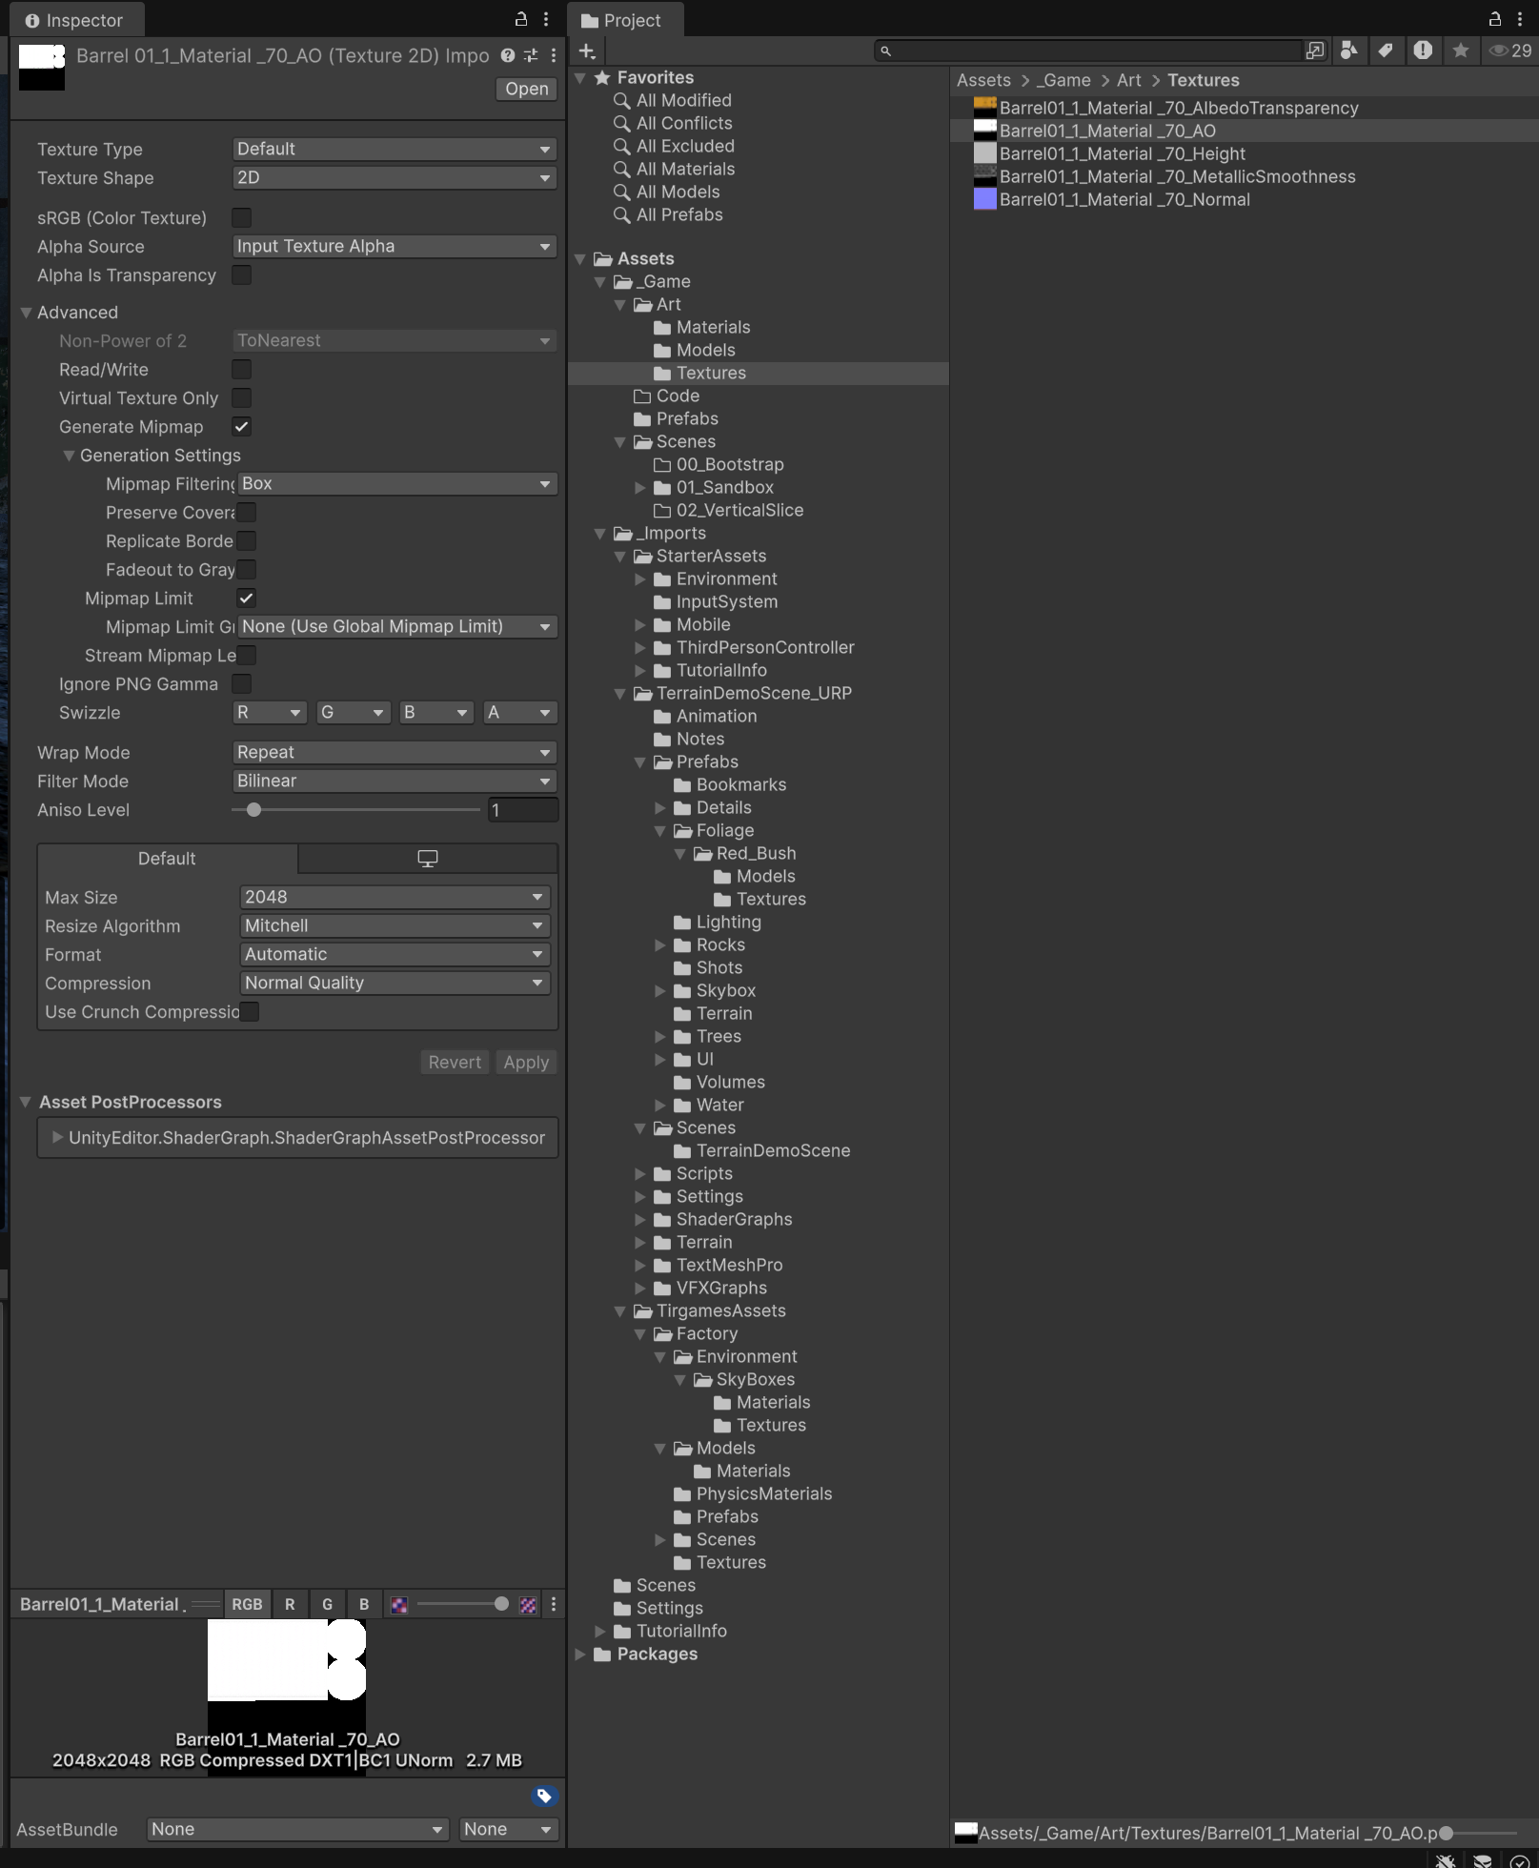

### Height Map

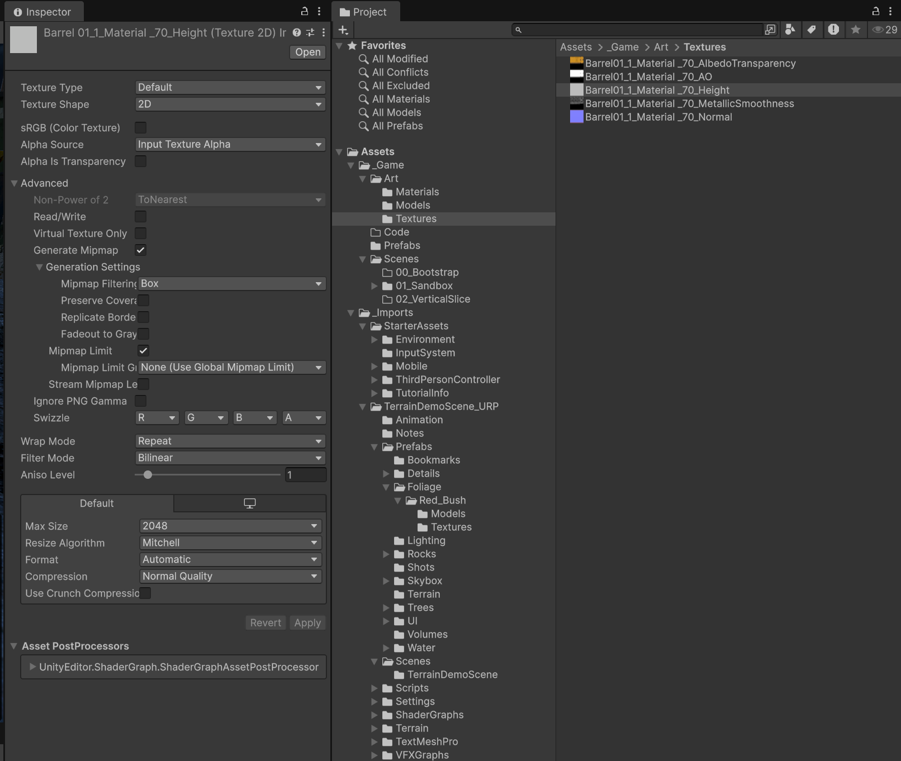

Notice that when sRGB is turned on we can see more of the ‘W’ compared to when sRGB turns off.

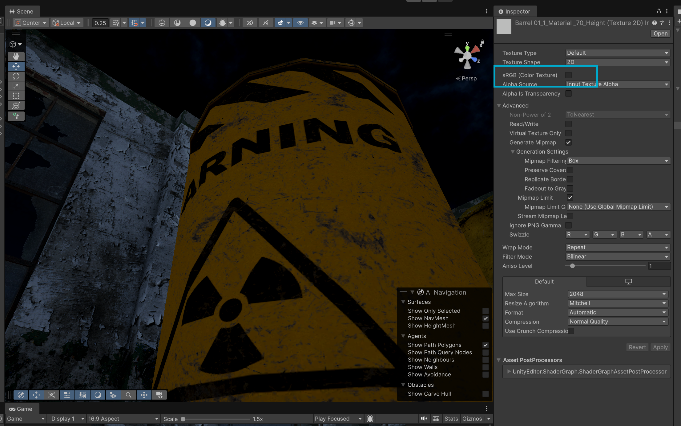

sRGB On: sRGB Off:

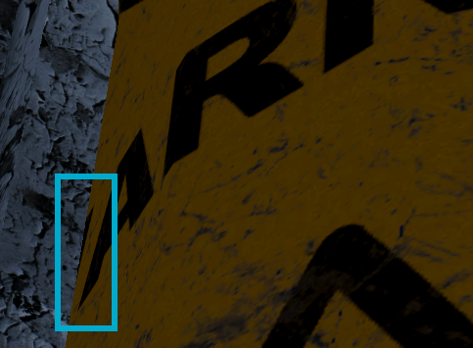 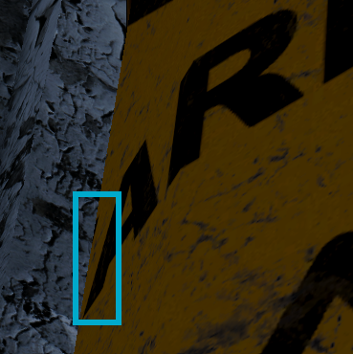

### Metallic Map

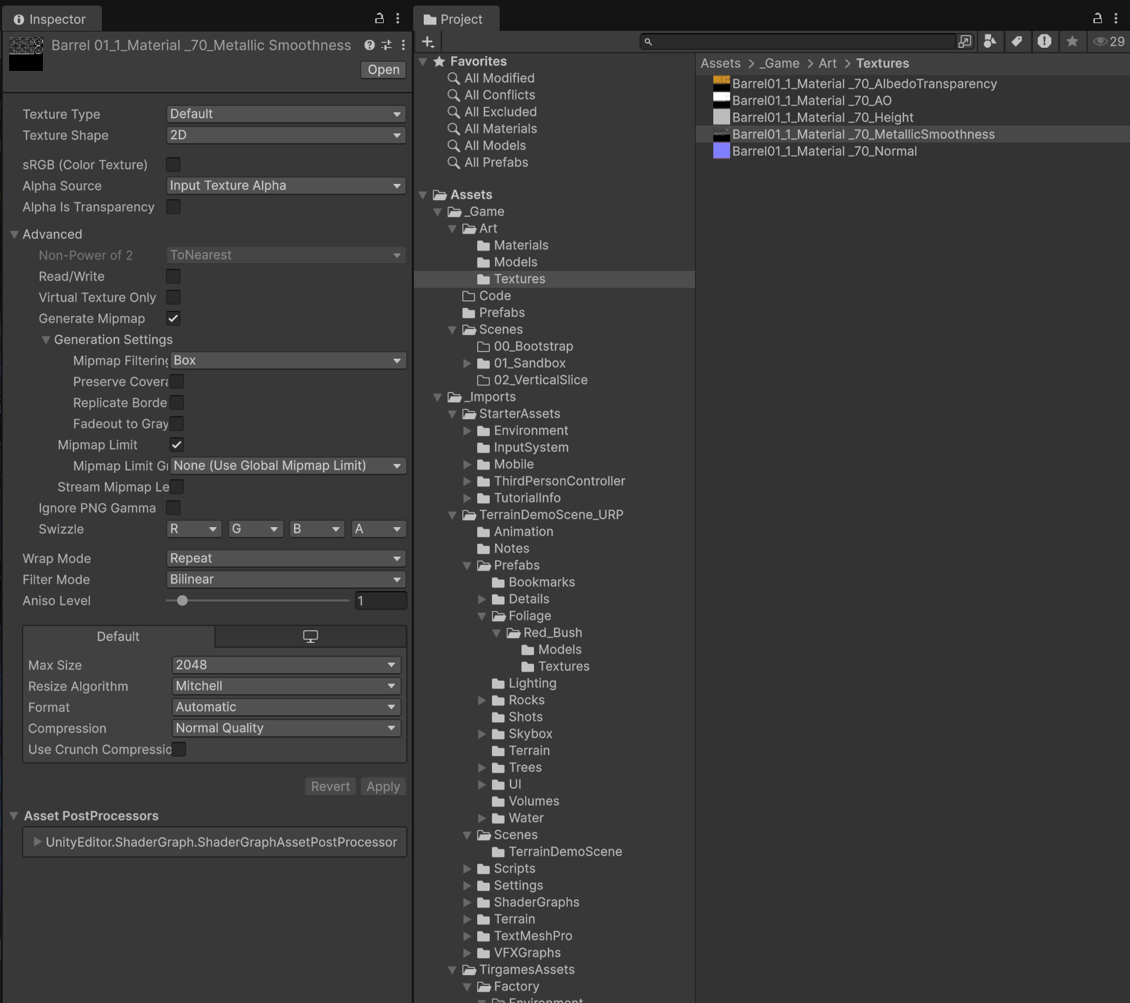

Looking at the screenshots below, when sRGB is turned off more scratches appear on the barrel giving off more of a rough texture.

sRGB on:

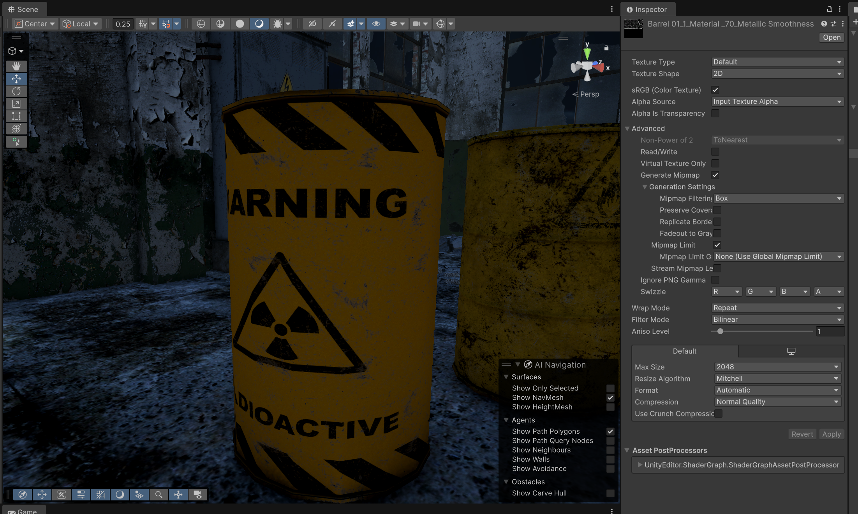

sRGB off:

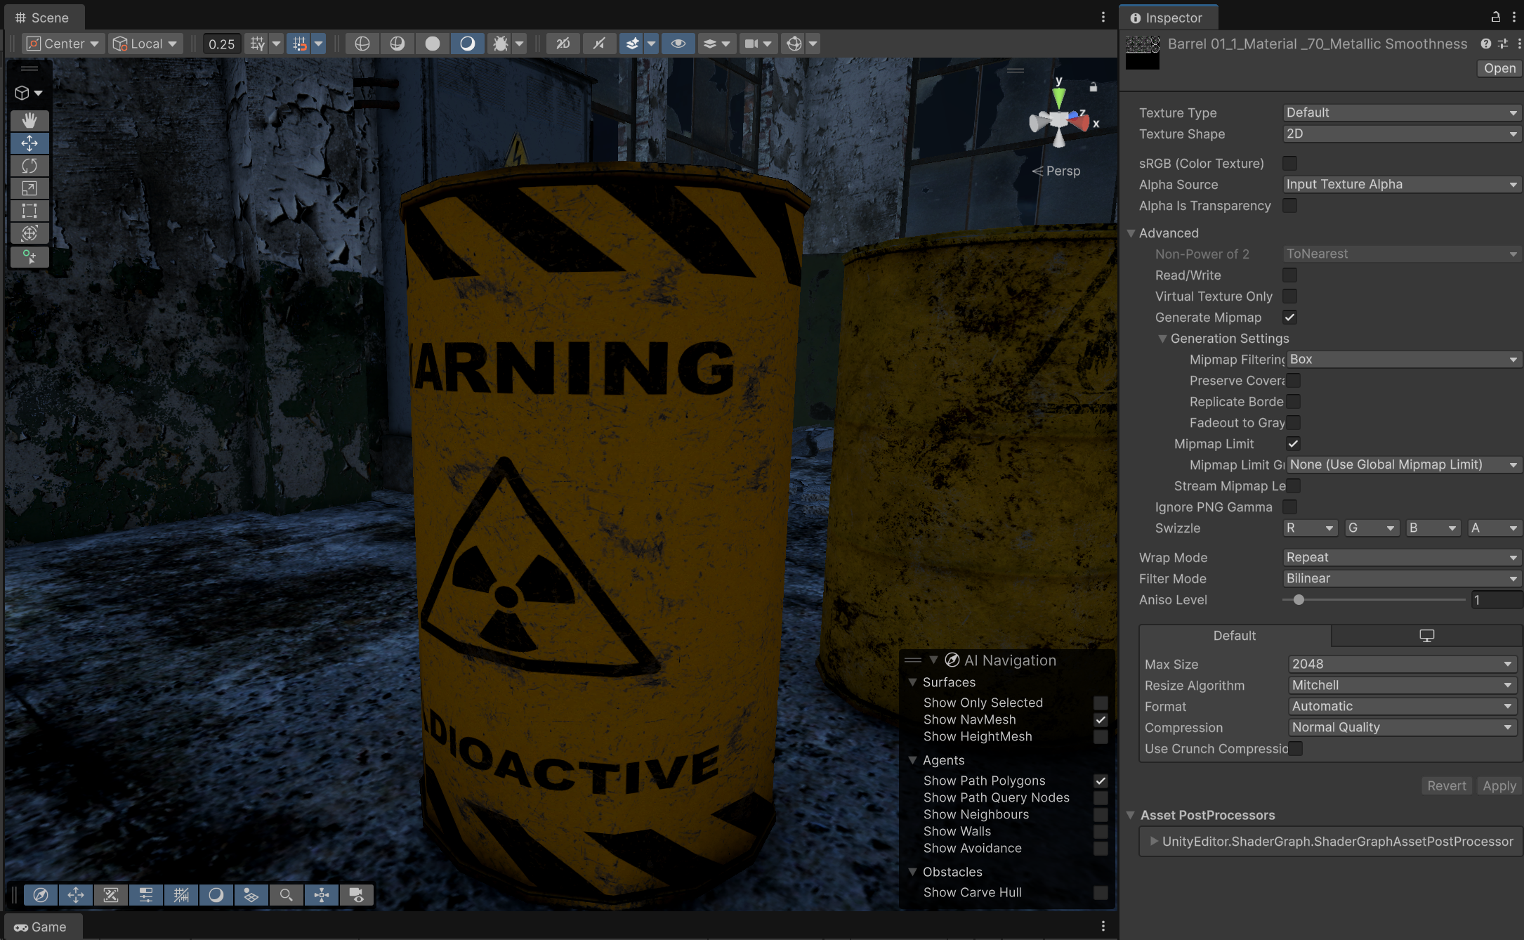

## Final Material

Once the maps are added the result looks like the following. The material uses a lit URP shader.

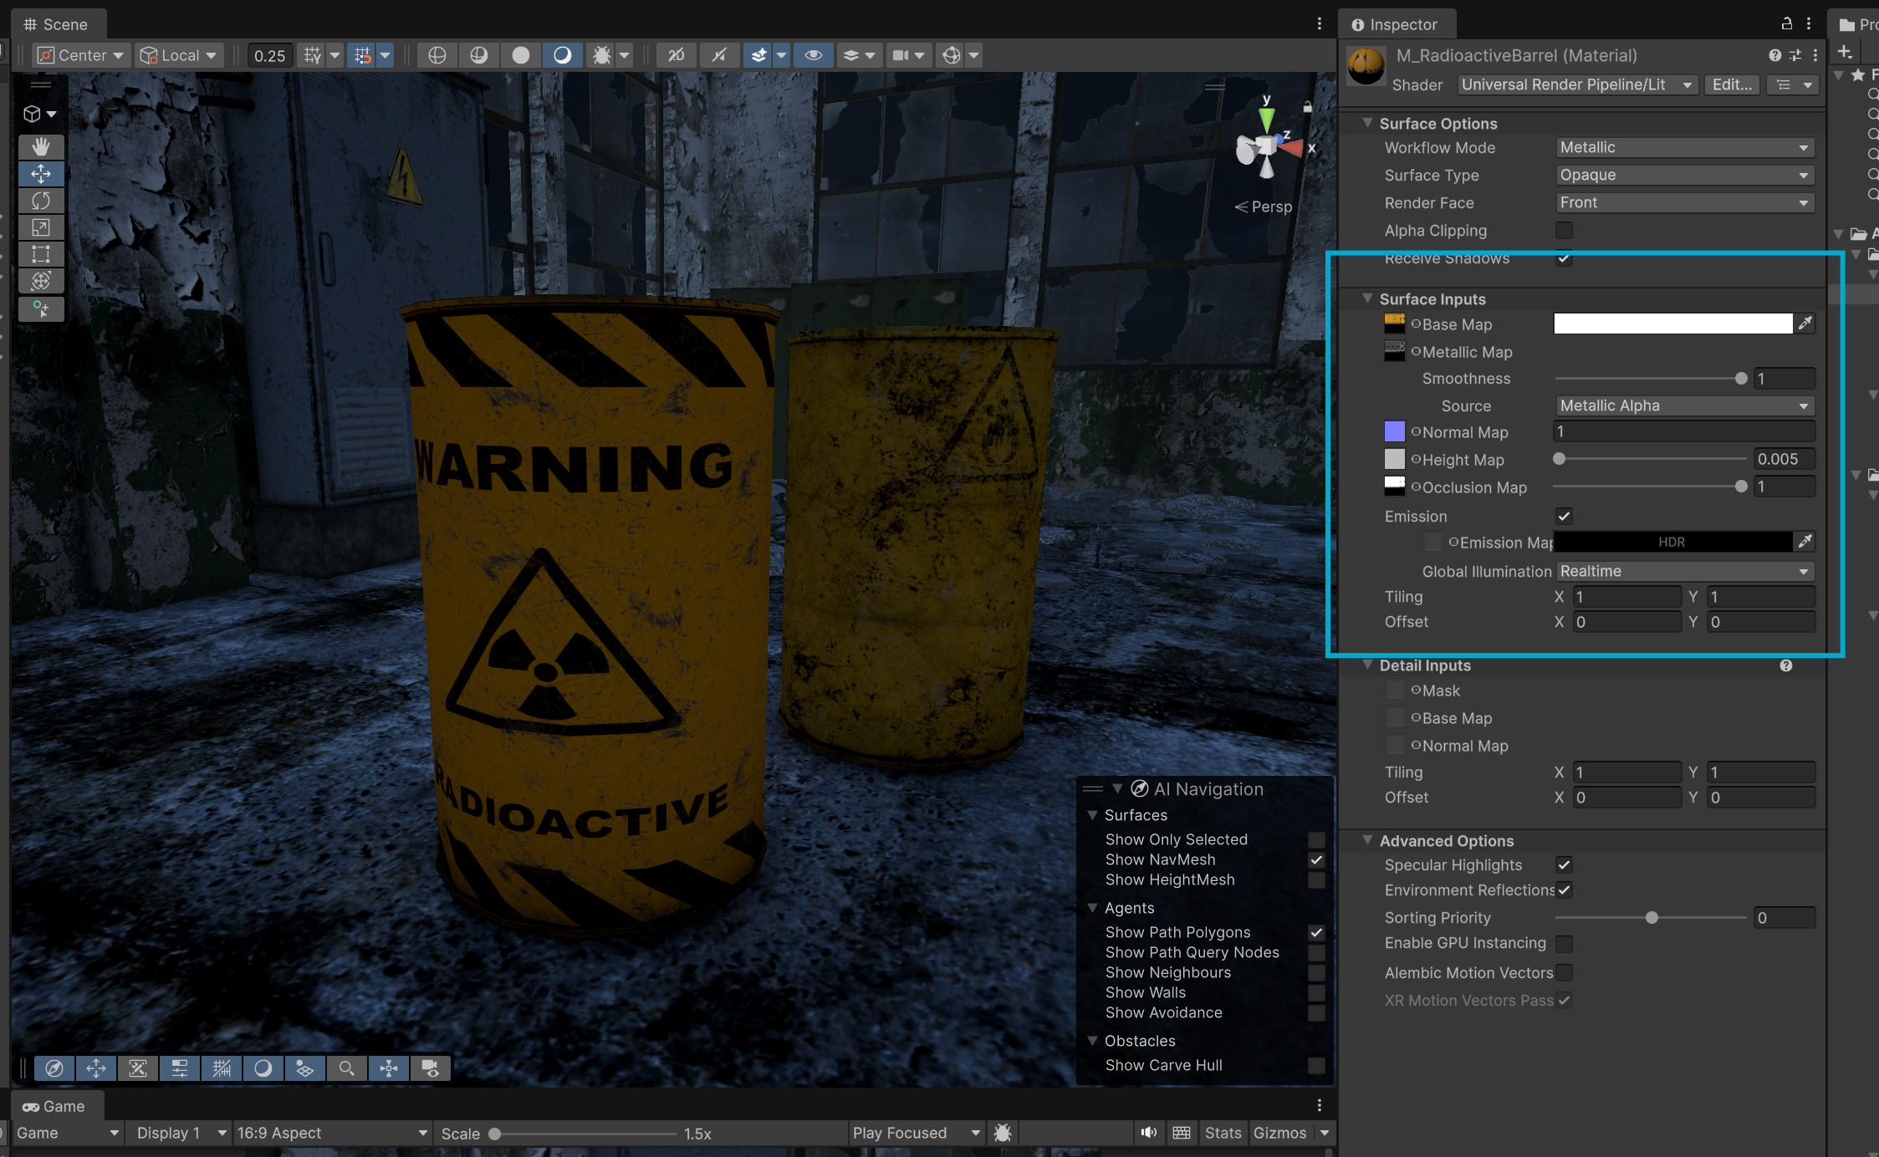

In the inspector, I keep the default surface options. The workflow is metallic since I am using a metal barrel as my subject. Surface type is opaque as the barrel is not see through.

The smoothness I set to 0.8. Smoothness affects how light reflects off of the surface of the barrel, since the barrel is made of a steel material, the values reflect how light would scatter as seen from the [documentation](https://docs.unity3d.com/6000.3/Documentation/Manual/StandardShaderMetallicVsSpecular.html).

In the screenshots below, when we have a smoothness of 1 when the lights are on, we can see more reflection from the barrel.

Smoothness: 0

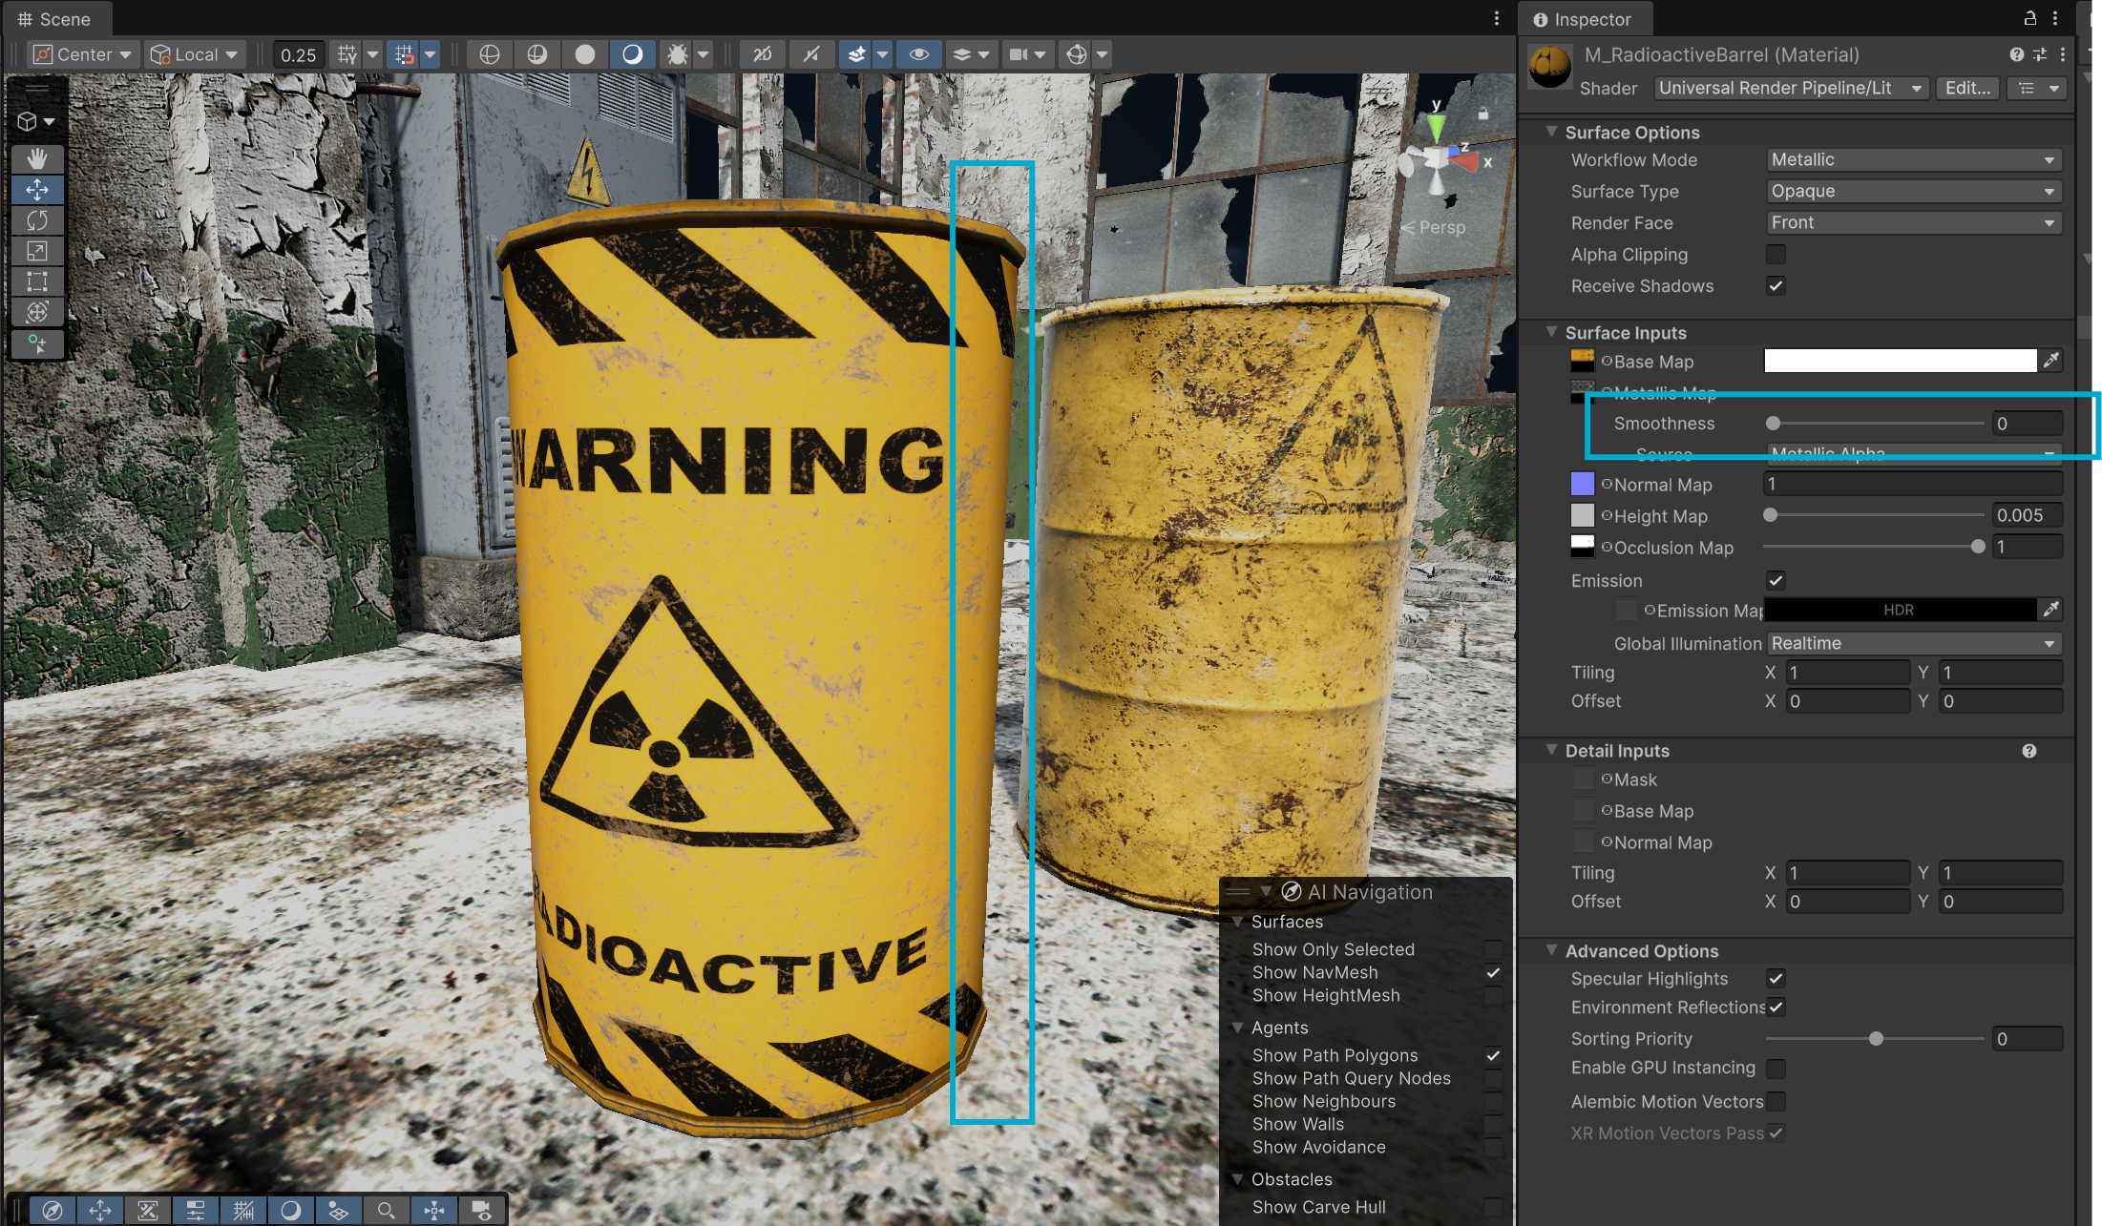

Smoothness: 1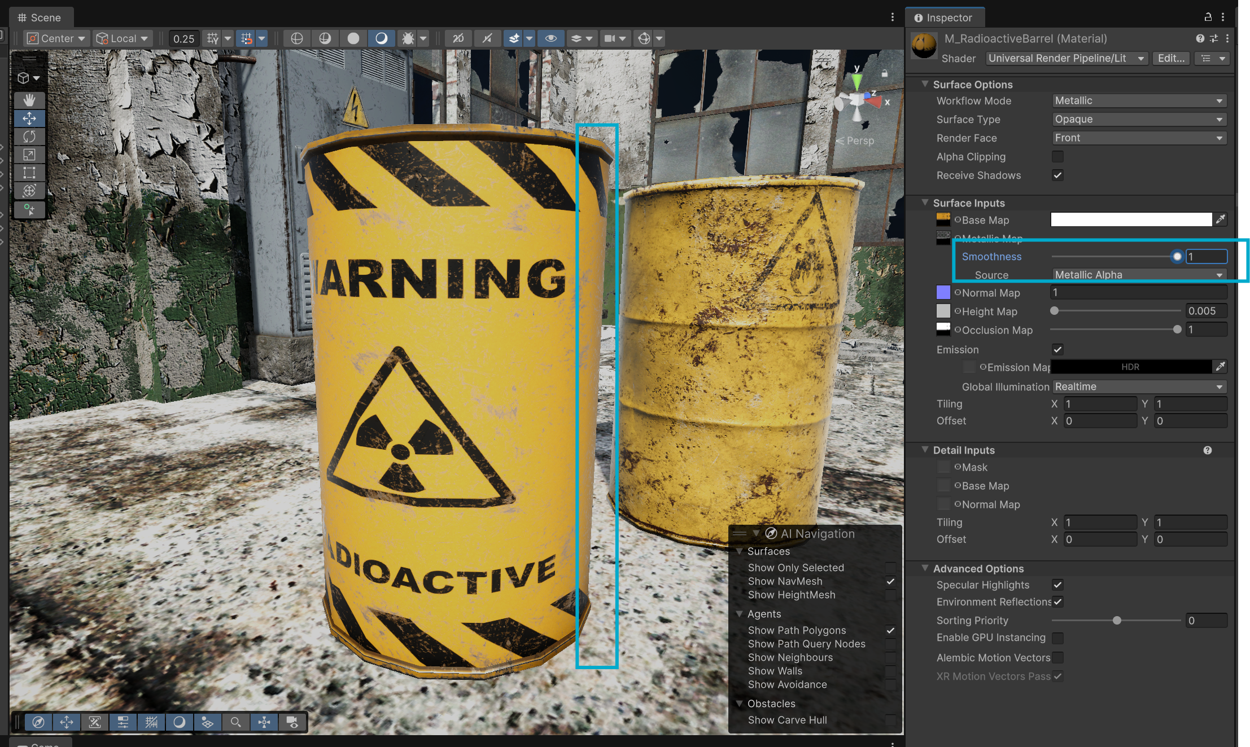

The height and occlusion can stay at the default values.

## Problem and Fix: Metallic Map

I encountered an issue where when I disabled the lighting, the barrel turned completely black.

I discovered that the reason for this is that metal objects need light to reflect, when it is dark, there is no light to reflect and as such the barrel appears black.

Looking back at the metallic map, the map appeared completely white, which means that the material is treated as 100% metal.

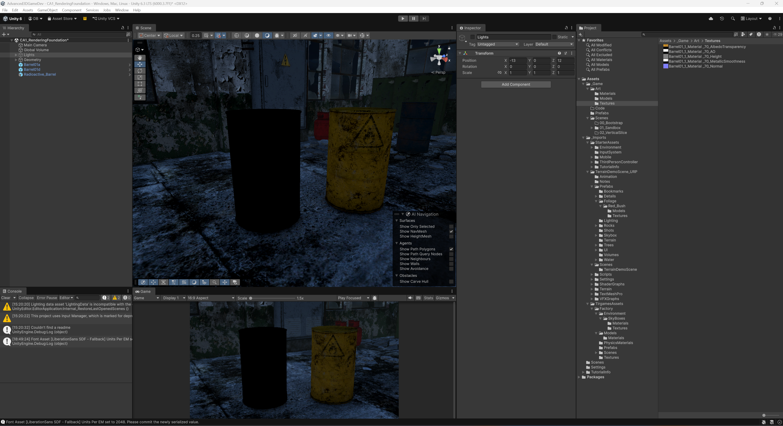

We can also confirm this by looking at the metallic map in substance painter like so. Notice that in the properties we can see that the metallic value is set to 1 for the base material.

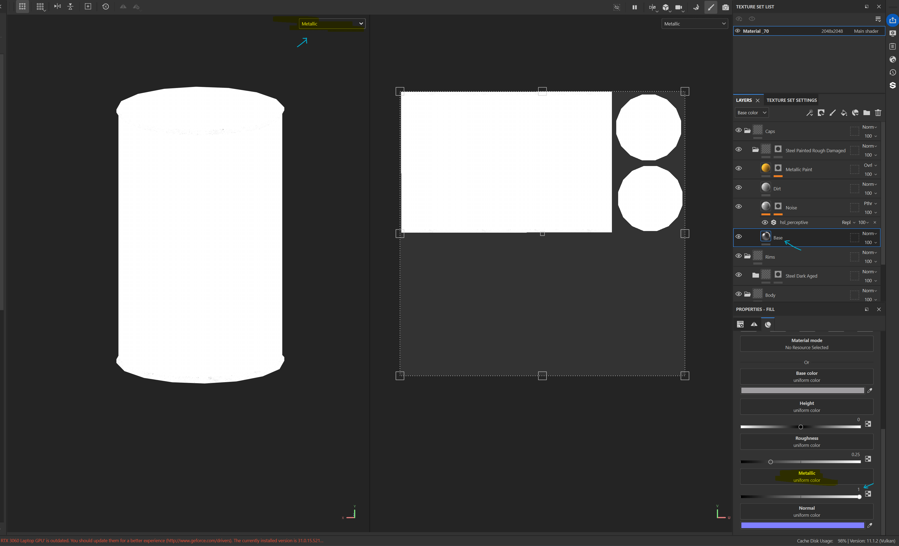

The problem comes from the paint material which by default has the metal material disabled. This material is what is used to give the material it’s colour, but we need to define that the paint material is non-metallic.

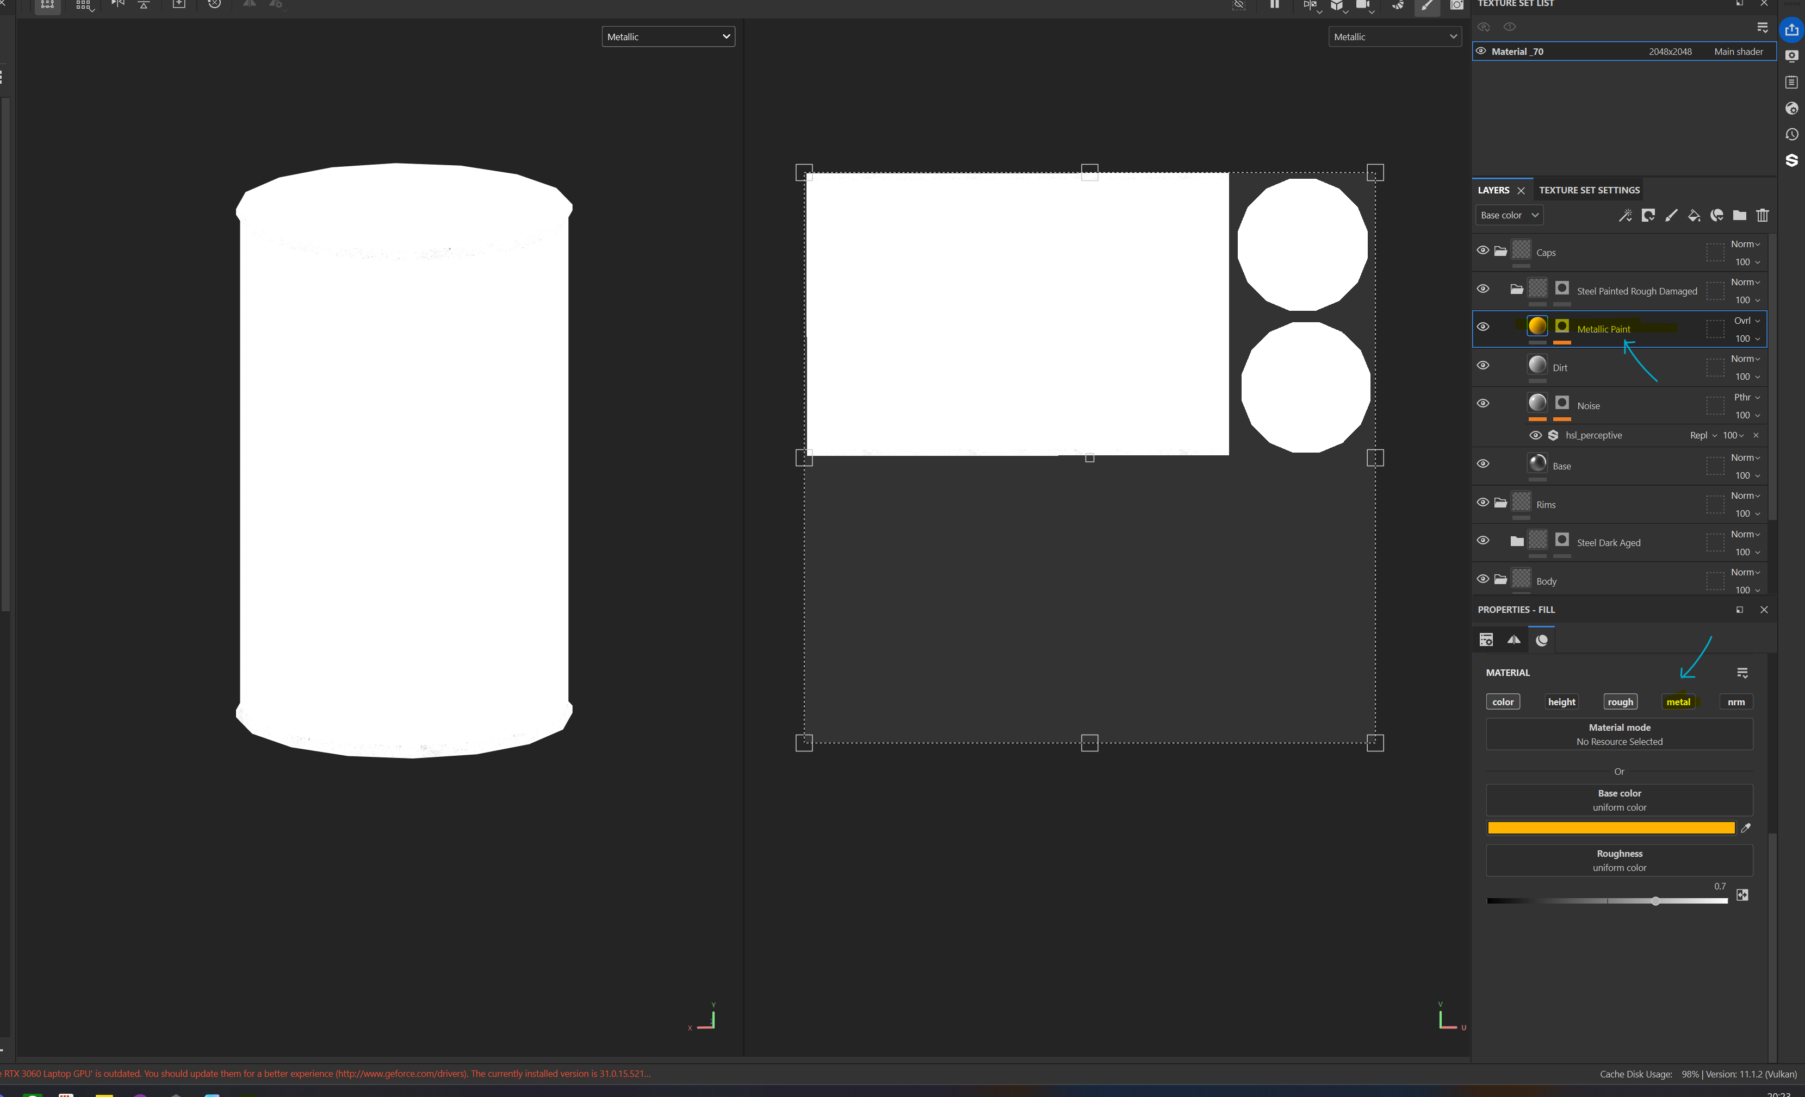

To fix this, I enabled the metal property and set the metallic value to zero which means that the material is not metal.

Note: The material is a metallic paint. Looking into it, this type of paint contains small metal flakes, but these flakes do not act like a metal hence why I set the value to 0.

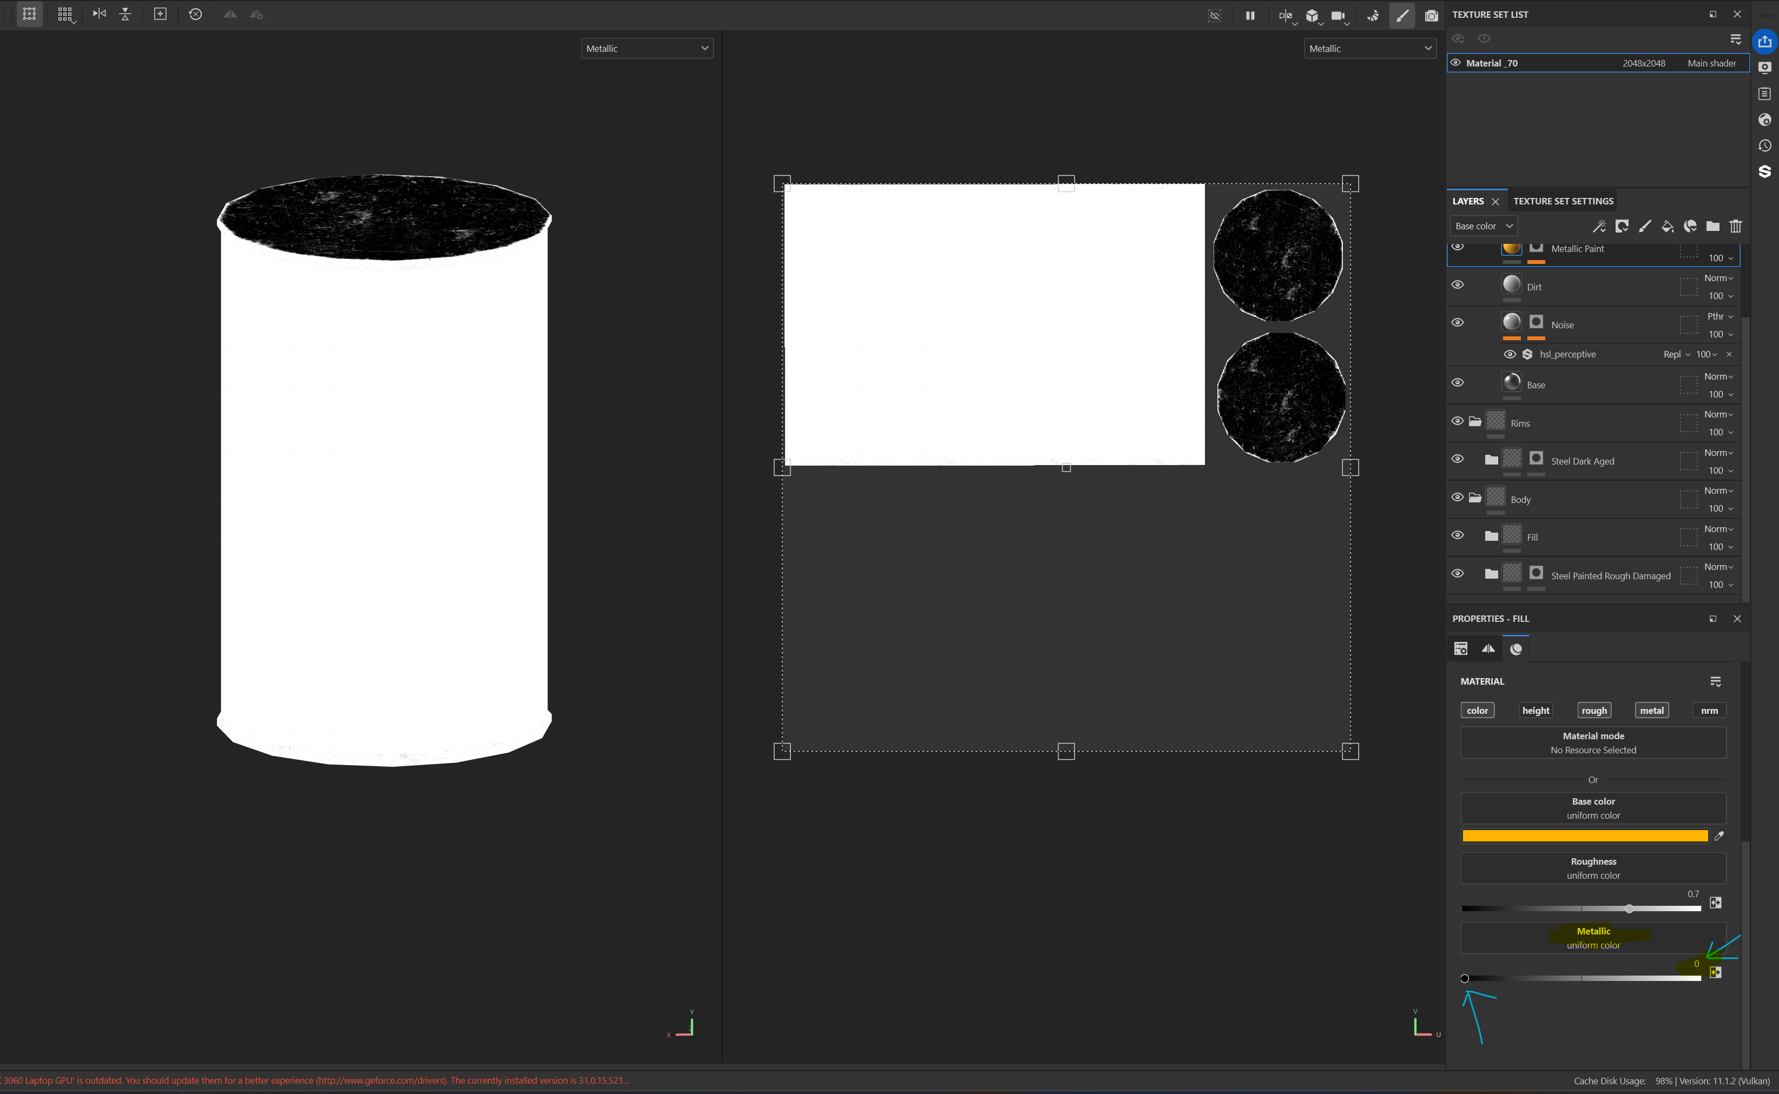

I did the same for the rest of the surfaces such as the body of the barrel and reimported the metallic map back into unity. As seen in the screenshot below, this fixed the issue.

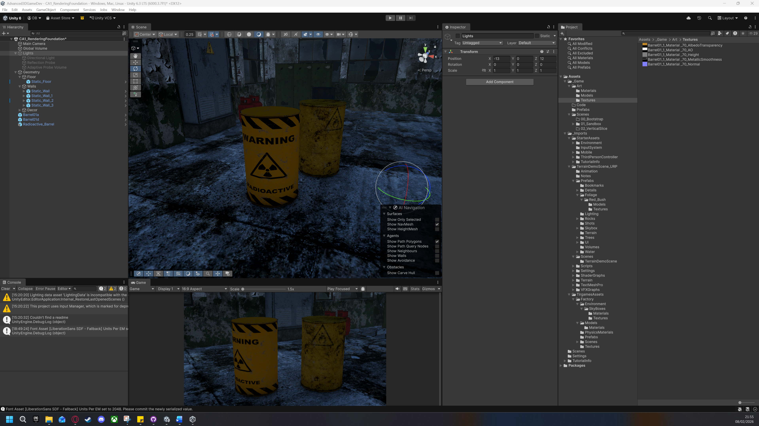

# Shader Graph + Dissolve Effect

Screenshot of the shader graph:

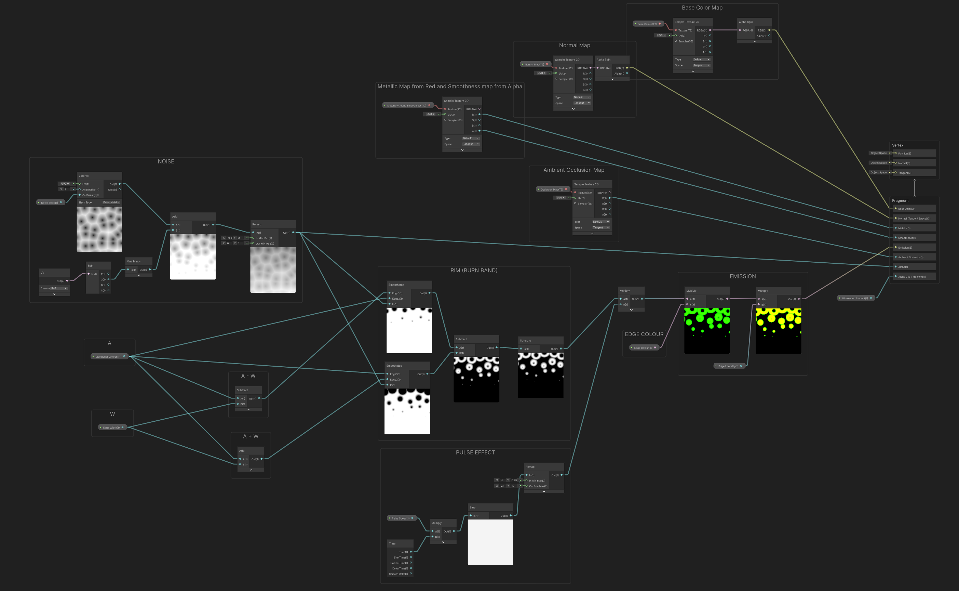

Inspector screenshot:

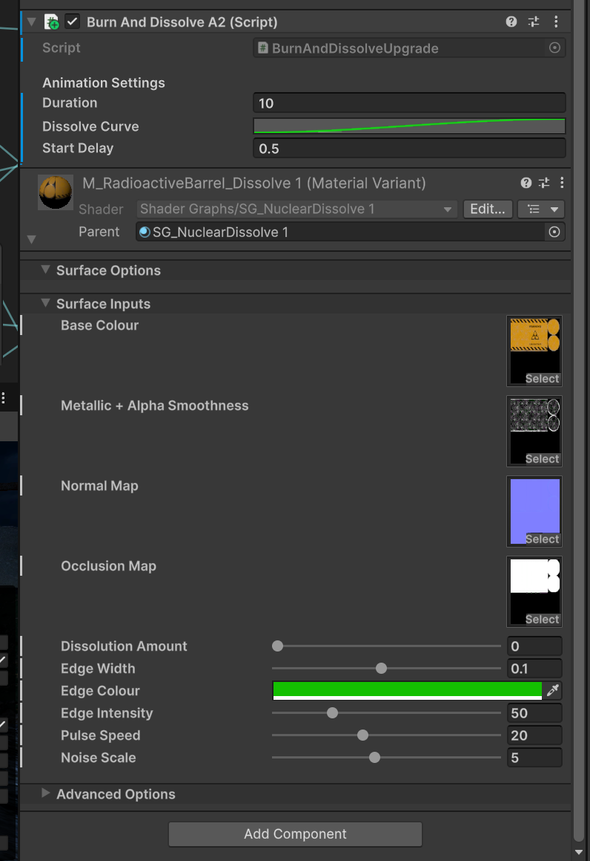

The moving burn edge is computed by creating a threshold window where two Smoothstep gradients, one offset slightly ahead of the dissolve amount and one behind, are subtracted from one another to isolate the erosion frontier. This mask is driven by a normalized Voronoi Noise and vertical UV gradient.

To simulate radioactive instability, I integrated a Time-based Sine wave to oscillate the emission intensity and used the noise to distort the texture UVs.

These parameters grant full artistic control over the edge width, colour and intensity, the speed of the pulse and the amount of noise.

# Scene Lighting

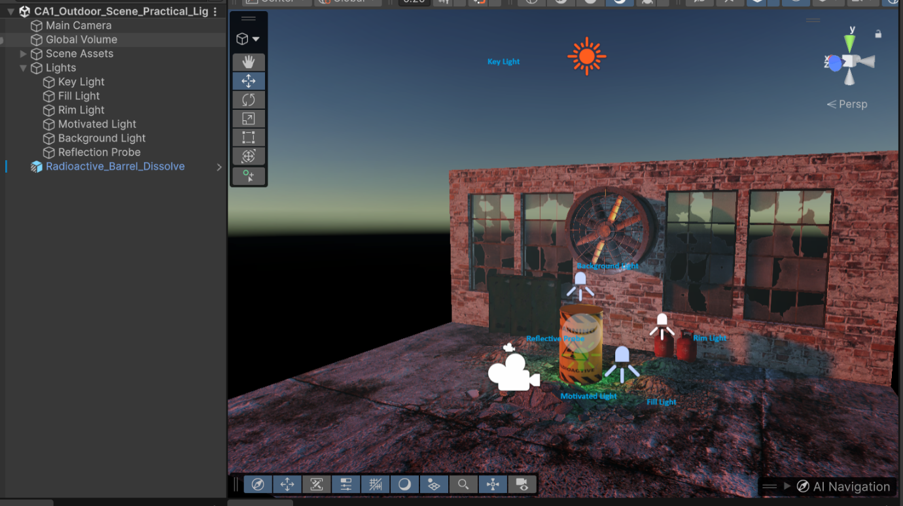

## How the helper lights contributed

The helper lights were used to enhance the asset's readability in a low-light dusk environment.

The Fill light was essential for brightening the dark side of the barrel, this helped to highlight the hard to see textures and ensuring the PBR material properties remained visible in the shadows.

To define the asset's form against the dark brick wall, a Rim light was used to create a crisp silhouette, effectively lightening the dark edges and providing clear separation from the background.

Finally, the Motivated Light was added for aesthetic depth; this toxic green light supports the radioactive emissive shader by casting a glow onto the surrounding rubble, grounding the effect within the 3D space.

## Performance and Quality Trade-offs

For the reflection support, I opted for a Realtime Reflection Probe to ensure the pulsing green glow and dynamic dissolve effects are accurately reflected on the barrel’s metallic surface.

To maintain high performance, I utilized a lightweight configuration by lowering the probe's resolution and using the On Awake refresh mode where possible to minimise per-frame GPU costs.

Additionally, while I enabled Soft Shadows for the Key light to maintain visual fidelity, I disabled shadows on the rest of the lights.

This allows for complex cinematic lighting and colour temperature filtering while significantly reducing the shadow-map rendering overhead.

.